DES’S NAVINCHANDRA MEHTA INSTITUTE OF TECHNOLOGY AND DEVELOPMENT,
MUMBAI – 400028



SUMMER INTERNSHIP REPORT ON

“ FUNDAMENTAL ANALYSIS OF METAL & MINING SECTOR “

Submitted in partial fulfilment for the award of the degree of

MASTER OF MANAGEMENT STUDIES
FINANCE
UNIVERSITY OF MUMBAI
Submitted by
Om Shrikant Misal
ROLL NO :- M -16130
2025-2027
Under The Guidance of
DR. RAHUL N. WADEKAR

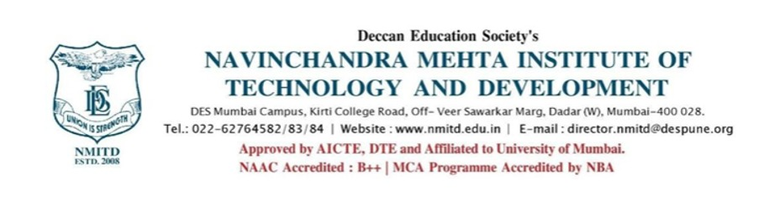

CERTIFICATE
This is to certify that the summer internship report titled “Fundamental Analysis of Metal And Mining Sector ” submitted in partial fulfilment for MMS Degree Examination by Om Shrikant Misal, is a record of Research work carried out by the student during the period from 2025 to 2027 under my guidance, and has been found satisfactory. This project work is original and not submitted earlier for the award of any degree, diploma or associateship of any other University/Institute.

--------------------------- ---------------------------
Dr. Rasika Mallya Dr. Rahul Wadekar
DIRECTOR PROJECT GUIDE

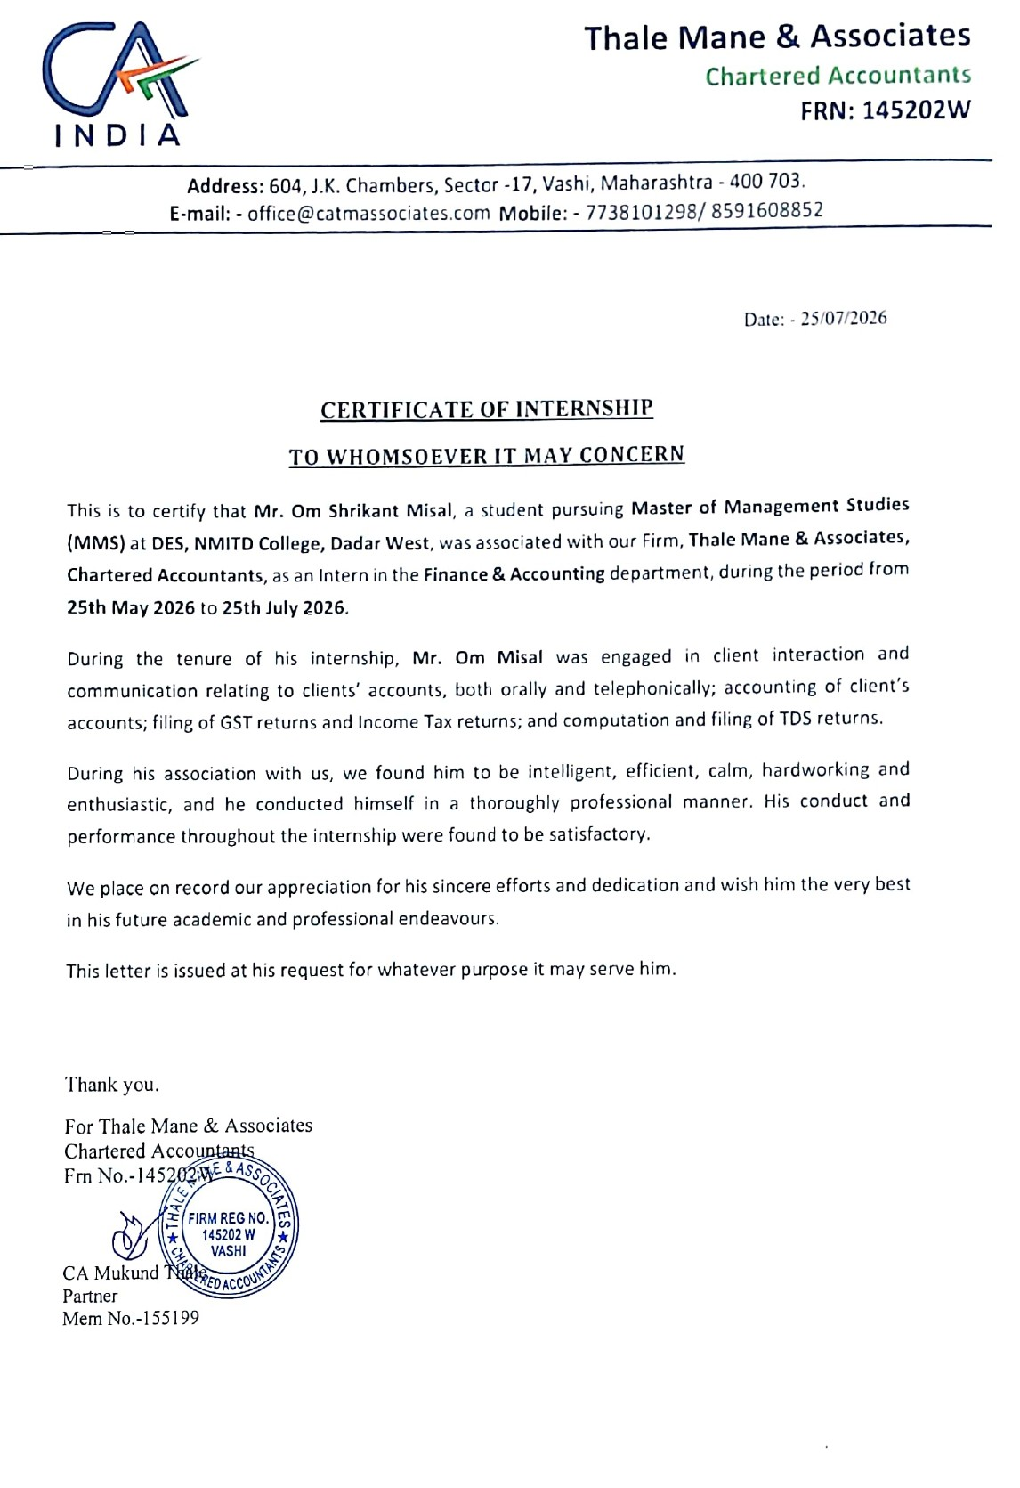

DECLARATION
I hereby declare that this project report submitted by me to the partial fulfillment of the requirement for the award of Master of Management Studies (MMS) of the University of Mumbai is a bonafide work undertaken by me and it is not submitted to any other University or Institute for the award of any degree, diploma/ certificate or published any time before.

Name : Om Misal Signature
Roll No. M-16130 (Om Misal)

ACKNOWLEDGEMENT
This project has been a tremendous learning experience, and I’m truly grateful to everyone who has supported me along the way. First and foremost, I want to extend my deepest thanks to our HOD. Dr. Rahul Wadekar, my internal project guide. His invaluable guidance an
d thoughtful suggestions made this project possible. His constant support and encouragement have been a source of inspiration, helping me channel my enthusiasm effectively. I am profoundly grateful to my parents, whose unwavering support and belief in me have been my greatest strength. I also want to express my sincere thanks to my friends, who have been incredibly committed and willing to help throughout my project work.
I would also like to extend my heartfelt thanks to all the professors and staff of DES’s NMITD, Lastly, I am grateful to everyone who indirectly supported me and contributed to the success of this project. Your cooperation and invaluable support have been much appreciated

EXECUTIVE SUMMARY
Summer training is crucial for management students, transforming them into well-rounded professionals. It bridges the gap between theoretical knowledge and practical application in real-world scenarios.
This project, titled “Fundamental Analysis of the Metal and Mining Sector,” focuses on determining the intrinsic value of securities by evaluating various economic and financial factors. This analysis is particularly valuable for investors seeking opportunities in Metal and Mining Sector companies. In today's competitive business environment, the Metal and Mining sector in India stands out for its intense competition.
Key financial statements used in this sector include balance sheets, which depict a company's financial position, and profit & loss statements, which reveal net profits and losses. Ratio analysis is a widely used method for evaluating an Metal and Mining company's performance over time. In my report, I analyzed the financial statements of Metal and mining sector Companies over the past three years. Through this process, I learned that ratio analysis is instrumental in identifying past shortcomings and informing future strategies.
Hence, it is essential for every organization, regardless of size, to prepare financial statements and analyze them using ratios. This approach not only enhances understanding of the company's financial health but also aids in making informed decisions for the future.

INDEX
CHAPTER NO. | CHAPTER TITLE / SUB-SECTION | PAGE NO.
 | TITLE PAGE | 1
 | CERTIFICATION | 2,3
 | DECLARATION | 4
 | ACKNOWLEDGEMENT | 5
 | EXECUTIVE SUMMARY | 6
 | TABLE OF CONTENTS | 7-8
CHAPTER 1 | INTRODUCTION | 9
 | 1.1 Need of the Study
 | 1.2 Objectives of the Study
 | 1.3 Scope of the Study
CHAPTER 2 | ORGANIZATIONAL BACKGROUND | 10-16
 | 2.1 Firm Introduction (Thale Mane & Associates) | 10
 | 2.2 Partners Profile
 | 2.3 Array of Services
 | 2.4 Vision
 | 2.5 Mission
 | 2.6 Departments
 | 2.7 Job Description | 11
 | 2.8 LEARNING ACTIVITIES FROM ORGANISATION | 12-16
CHAPTER 3 | FUNDAMENTAL ANALYSIS - SECTOR OVERVIEW | 17-18
 | 3.1 Importance of Metals & Mining Sector | 17
 | 3.2 Industry-Wide Advantages & Disadvantages | 17
 | 3.3 Sector Challenges | 18
 | 3.4 Top 10 Indian Metals & Mining Companies Overview | 18
CHAPTER 4 | RESEARCH METHODOLOGY | 19-22
 | 4.1 Research Design & Objectives | 19
 | 4.2 Scope & Sources of Data | 19
 | 4.3 Sample Selection & Period of Study | 20-22
CHAPTER 5 | EIC FRAMEWORK (ECONOMIC, INDUSTRY & COMPANY ANALYSIS) | 23-48
 | 5.1 Economic Analysis (Macroeconomic Factors & Current Indian Economy) | 23-26
 | 5.2 Industry Analysis (Metals & Mining Industry Drivers & Trends) | 27-28
 | 5.3 Company Analysis - JSW Steel Ltd. | 29-35
 | 5.4 Company Analysis - Tata Steel Ltd. | 36-42
 | 5.5 Company Analysis - Hindalco Industries Ltd. | 43-48
CHAPTER 6 | COMPARATIVE RATIO ANALYSIS & INTERPRETATION | 49-68
 | Factor analysis | 68
CHAPTER 7 | CONCLUSION, F INDINGS & SUGGESTIONS | 77
 | REFERENCES / BIBLIOGRAPHY
APPENDICES | TATA STEEL COMPANY ANALYSIS RESEARCH REPORT | 84-111

CHAPTER 1 :-INTRODUCTION

1.1 NEED OF THE STUDY
- To gain exposure to the corporate world.
- To understand the Metal and mining sector fundamentally.
- To know how economic changes, natural calamities, and crises impact the industry.
- To predict the future of the Metal and mining sector with the help of research, fundamental, and economic analysis.
- To study the ratio analysis of selected Metal and mining sector companies.
1.2 OBJECTIVE OF THE STUDY
- To study the changes the organization has undergone in the recent past or have initiated recently.
- To study fundamental and technical analysis.
1.3 SCOPE OF THE STUDY
This project will allow investors to refer to the performance of Metal and mining companies, their relative growth, and decide whether to invest in particular shares. The project is limited to the fundamental analysis of the selected Metal and mining companies for a given period; other analyses and Metal and mining companies not present in this list are not considered

CHAPTER 2:- ORGANIZATIONAL BACKGROUND

2.1 ORGANISATIONAL INTRODUCTION
About Firm
Thale Mane & Associates is a chartered accountancy firm registered with the Institute of Chartered Accountants of India (ICAI) having its operations mainly in the city of Mumbai and Navi Mumbai. With a combination of experience, enthusiasm, knowledge, resources and positive approach of our partners and staff, we provide services to large number of satisfied clients belonging to various sectors across India.
Our experienced team shall guide you in each and every aspect of your business, right from incorporation to day-to-day compliance, accounting related issues, return filing, assessments, litigation and other miscellaneous issues with due professional care in line with code of ethics issued by ICAI.
2.2 Partners
CA. Mukund Thale, (B.Com, FCA)
Founder Partner of the Firm, has more than 10 years experience in rendering Corporate Advisory services. He has handled several assignments relating to Statutory Audits and International Taxation. He has carried out various assignments for Due Diligence. He is specialized in direct and indirect taxation which includes Income Tax, GST, VAT, Service Tax, RERA, FEMA etc.
CA. Swapnil Mane, (B.Com, ACA)
Founder Partner of the Firm, has more than 5 years of experience in providing professional and management services in the areas of Accounts and Audits.
He renders advisory, planning and compliance services for various large corporate on Services Tax & Income Tax matters. He is heading Audit and assurance services like Statutory Audit, Tax Audit, Internal Audit, Stock and Receivables audit.He provides services for start-ups along with Accounting, Company law advisory and compliance services for Corporate.
2.3 Array Of Services
Direct Taxation
Advising on Tax related matters as may arise from time to time, Advising on Withholding Tax issues, Issue of Certificates for Remittances, Assisting in preparation/review of Income Tax Returns of expatriates/employees in India, etc.
Indirect Taxation
Advising on the taxability of transactions under India’s Indirect Tax as may arise from time, Representation before tax authorities inconnection with assessment andappealsof the company, etc.
GST
Advisory and implementation of GST Law and recent amendments.
Business Analysis, Project report along with assist in execution
Company Law
Opinions, comments, clarifications, on company law matters, Company Law Board Filing, Minutes of Company, Due Diligence of Company, etc.
Company Formation
Formation of Company of various classes such as Private Limited, Public Company, Section 25 company in India, etc.
Statutory Audit & Accounting
Assisting in maintaining the account records of the companies, the statutory audit of the financial statements of companies as required under the Companies Act, VAT audit, GST Audits, etc.
Corporate Finance, Banking and Investment
Fund raising for business ventures both as Debt & Equity, Assignment related to Restructuring, Valuations.
Non Resident Taxation
Tax Advisory Services and filing of e-Tax returns, Setting up a Branch office/ Liaison office/ Project office in India, Banking and Remittances, filling PAN application etc.
Remittance Certifications
Advising on the applicability of withholding tax on various foreign remittances as per Indian Income tax Act / DTAA, issuing foreign remittance certificates etc.
FEMA Consultancy
Advisory services on Foreign direct Investment, Overseas direct Investment, Filling APR & FLA, FCGPR compliance etc.
2.4 Vision
To be a trusted and respected Chartered Accountancy firm known for professional excellence, integrity, and reliable financial solutions, while creating long-term value for clients.
2.5 Mission
To provide accurate, ethical, and timely services in accounting, taxation, auditing, compliance, and financial advisory by understanding clients’ needs and delivering practical solutions through professional expertise and technology.
2.6 Departments
1. Professional Services: Audit, Taxation, Company set-up and registration, professional financial recruitment and legal services covering patent and trademark registration, business contracts and employment contracts.
2. Financial Accounting: outsource accounting services from the provision of CFO services to bookkeeping, payroll and office administration, including company policy and procedure manuals.
3. Management Accounting: market growth related services including training and assistance in budgeting, forecasting, cash flow management and business strategy. .
4. Systems Solutions: efficiency improvement services, including review and implementation of management information systems and surrounding processes.
5. Business Management: management consulting and corporate finance services, including assistance with market entry strategy, mergers, acquisitions and divestitures, business and financial due diligence, business investigation, internal communication and M&A integration.
2.7 Job Description
• Prepared financial statements, including Income Statements, Balance Sheets, and Cash Flow Statements.
• Prepared contracts and documents for transactions.
• Managed and updated the client database and contact information.
• Prepared computations for income tax under various heads
• Scheduled and coordinated client meeting
2.8 Learning Activities from Organisation
Income Tax
An Income Tax Return (ITR) is a structured form submitted to the Income Tax Department of India. It contains details of a taxpayer's annual income, tax liabilities, deductions, and taxes paid (TDS/Advance Tax) during a specific Financial Year (FY). Filings are processed in the subsequent Assessment Year (AY), which is the year your income is reviewed and taxed.
The income tax system in India follows a simple rule: The more you earn, the higher the tax rate you pay. This ensures that the tax burden is shared fairly based on each person's financial situation.
Income Tax work
To make the process fair and organized, the tax department groups your money into five main categories, known as the Five Heads of Income:
Salary Income: The fixed monthly pay, bonuses, and allowances you receive from your employer if you are a salaried worker.
House Property Income: The money you earn from renting out a house, shop, or building that you own.
Business or Professional Income: The profits earned from running a shop, factory, or corporate business, or the fees earned by professionals like CAs, doctors, lawyers, and freelancers.
Capital Gains: The profit you make when you sell an asset for a higher price than you bought it (such as selling property, jewelry, or stock market shares).
Income from Other Sources: A catch-all category for any other earnings, including bank account interest, lottery wins, puzzle prizes, or dividends from investments.

1 .Old Tax Regime (The Deduction-Based System)
The Old Tax Regime is the traditional tax framework. It features higher progressive tax rates but allows taxpayers to significantly lower their net taxable income by claiming various statutory exemptions and deductions.
Key Strategy: Beneficial for individuals with high investments, home loans, or medical expenses.
Major Deductions Allowed:
Section 80C: Up to ₹1,500,000 for investments in PPF, ELSS mutual funds, LIC, and School Fees.
Section 80D: Up to ₹25,000 (or ₹50,000 for senior citizens) for medical insurance premiums.
Section 24(b): Up to ₹2,00,000 for interest paid on home loans for self-occupied properties.
House Rent Allowance (HRA) & Leave Travel Allowance (LTA): Exemptions on employment allowances.
Standard Deduction: Fixed deduction of ₹50,000 for salaried individuals
2. The New Tax Regime (The Concessional, Zero-Exemption System)
The New Tax Regime is the default tax system for FY 2026–27 / AY 2027–28. It simplifies tax filing by offering much lower, granular slab rates and wider income brackets, but it removes almost all traditional deductions and exemptions.
Key Strategy: Beneficial for individuals who prefer higher disposable income over locked-in long-term investments, or those with minimal tax-saving investments.
Deductions Sacrificed: Assessees give up Section 80C, 80D, HRA exemptions, and Section 24(b) home loan interest deductions.
Retained Benefits & Enhancements:
Enhanced Standard Deduction: Raised to ₹75,000 for salaried employees.
Section 87A Tax Rebate: Extended to provide a full tax waiver for individuals with a net taxable income up to ₹1,200,000 (meaning zero net tax is paid up to this threshold).
Income Tax Slab Rates: Old vs. New Regime
Income Tax Slab Rates
Tax Rate | Old Tax Regime | New Tax Regime
Nil | Up to ₹2,50,000 | Up to ₹4,00,000
5% | ₹2,50,001 to ₹5,00,000 | ₹4,00,001 to ₹8,00,000
10% | N/A | ₹8,00,001 to ₹12,00,000
15% | ₹5,00,001 to ₹10,00,000 | ₹12,00,001 to ₹16,00,000
20% | N/A | ₹16,00,001 to ₹20,00,000
25% | N/A | ₹20,00,001 to ₹24,00,000
30% | Above ₹10,00,000 | Above ₹24,00,000

Comparative Computation
Particulars | Old Tax Regime | New Tax Regime
Gross Salary Income | ₹15,00,000 | ₹15,00,000
Less: Standard Deduction | (-) ₹50,000 | (-) ₹75,000
Less: Exemptions (HRA, LTA) | (-) ₹50,000 | Not Allowed
Gross Total Income (GTI) | ₹14,00,000 | ₹14,25,000
Less: Chapter VI-A Deductions (80C & 80D) | (-) ₹2,00,000 | Not Allowed
Net Taxable Income | ₹12,00,000 | ₹13,50,000
Slab-Wise Tax Calculation:
- Up to ₹2,50,000 / ₹4,00,000 | Nil | Nil
- Next slab (5%) | ₹12,500 | ₹20,000
- Next slab (10% / 15%) | ₹75,000 | ₹40,000
- Next slab (20% / 25%) | ₹40,000 | ₹22,500
Base Tax Payable | ₹1,27,500 | ₹82,500
Less: Tax Rebate (Section 87A) | Nil | Nil
Add: Health & Education Cess (4%) | ₹5,100 | ₹3,300
Total Net Tax Liability | ₹1,32,600 | ₹85,800

ITR Forms
Choosing the correct return form depends on the source of income, corporate classification, and asset ownership:
ITR-1 (Sahaj): For resident individual assessees with Total Income up to ₹50 Lakhs, derived from Salaries, Single House Property, or Income from Other Sources.
ITR-2: For Individuals and HUFs not carrying out business or professional operations, but reporting Capital Gains, Multiple House Properties, or Foreign Assets/Unlisted Equity.
ITR-3: For Individuals and HUFs running a proprietary business, trade, or professional practice (under auditing sections 44AB).
ITR-4 (Sugam): For Individuals, HUFs, and Firms (excluding LLPs) with income up to ₹50 Lakhs opting for Presumptive Taxation Schemes under Sections 44AD or 44ADA.
ITR-5: For corporate partnerships including LLPs, Association of Persons (AOPs), and Body of Individuals (BOIs).
ITR-6: For Corporate Entities registered under the Companies Act, unless claiming specific religious or charitable deductions.
ITR-7: For institutional bodies, trusts, NGOs, and political parties filing under Sections 139(4A) through 139(4D).
GST
The Goods and Services Tax (GST) is a comprehensive, multi-stage, destination-based indirect tax levied on the manufacture, sale, and consumption of goods and services across India. Enacted to establish a unified market under the motto "One Nation, One Tax", it effectively replaced a complex web of legacy indirect taxes (such as Central Excise, Service Tax, VAT, Octroi, and Entry Tax), eliminating the cascading "tax-on-tax" effect.
The Four Types of GST
India adopts a dual GST model, meaning taxation power is shared concurrently between the Central and State Governments depending on the geographical boundary of the transaction:
A. Intra-State Supplies (Transactions within the same State/Union Territory)
When goods or services are sold within the boundaries of a single state (e.g., a manufacturer in Vashi, Navi Mumbai sells goods to a trader in Dadar, Mumbai), the tax collected is split equally into two components:
CGST (Central Goods and Services Tax): Revenue collected by the Central Government.
SGST (State Goods and Services Tax): Revenue collected by the respective State Government (e.g., Maharashtra Govt).
Example: On a 18% GST invoice within Mumbai, 9% goes to CGST and 9% goes to SGST.
B. UTGST (Union Territory Goods and Services Tax)
This replaces SGST whenever a transaction occurs strictly within a Union Territory that does not have its own state legislature (such as Andaman & Nicobar Islands, Lakshadweep, or Daman & Diu). It is combined with CGST exactly like SGST.
C. Inter-State Supplies (Transactions between different States/UTs)
When goods or services cross state boundaries (e.g., a service provider in Vashi, Maharashtra consults for a corporate client in Bangalore, Karnataka), a single combined tax is levied:
IGST (Integrated Goods and Services Tax): Revenue is collected entirely by the Central Government, which then distributes the state's share to the destination (consuming) state.
Example: On an inter-state invoice of 18%, the entire 18% is billed directly as IGST
TDS
Tax Deducted at Source (TDS) is a mechanism introduced by the Income Tax Department to collect taxes right at the very source of income generation. Under this framework, any financial entity or person making a specified payment (like salary, professional fees, rent, or commission) is statutorily required to deduct a fixed percentage of tax before remitting the balance amount to the receiver (payee).
2. How the TDS Mechanism Operates
The entire transaction cycle revolves around two key economic participants:
Deductor: The person or corporate enterprise responsible for making the payment and deducting the tax (e.g., an employer, a corporate client, or a tenant). The deductor must possess a TAN (Tax Deduction and Collection Account Number) to deposit this tax.
Deductee: The individual, professional, or vendor who receives the net payment after the tax deduction (e.g., an employee, a consultant, or a landlord).
Quarterly Return Filing: Compiling data to file quarterly TDS returns using specific forms on the e-filing portal:
Form 24Q: Quarterly return for TDS on Salaries.
Form 26Q: Quarterly return for TDS on all non-salary payments to residents.
Form 27Q: Quarterly return for TDS on payments made to Non-Residents

CHAPTER 3 :-FUNDAMENTAL ANALYSIS.

1. Importance of the Metals & Mining Sector
- Industrial Backbone: It provides indispensable base raw materials directly to primary growth engines including construction, infrastructure, automotive frameworks, heavy engineering, and power networks.
- Macroeconomic Pillar: The sector is a primary contributor to India’s real Gross Domestic Product (GDP), infrastructure capex execution, baseline manufacturing jobs, and vital foreign exchange earnings through global exports.
- Clean Energy Transition Catalyst: Emerging core subdivisions within the sector provide critical minerals (such as Copper, Lithium, Cobalt, and Nickel) required to fuel electric vehicle (EV) supply chains and grid-scale renewable energy storage.
2. Industry-Wide Advantages & Disadvantages
Advantages
- Structural Cost Immunity: India possesses a unique geographic distribution of rich, high-grade mineral repositories (particularly iron ore and bauxite), allowing companies with backward integration to achieve exceptionally low production overheads.
- Robust Multi-Sector Demand: The market enjoys multi-year consumption tailwinds driven by the central government's infrastructure push, housing schemes, and an expanding local consumer retail sector.
- Strong Sovereign Policy Buffers: Tailored policy interventions—such as the National Critical Mineral Mission and Performance Linked Incentive (PLI) schemes for specialty steel—actively suppress import dependency.
Disadvantages
- Extreme Cyclicality: Sector corporate earnings are highly vulnerable to volatile macro commodity pricing cycles set on global bourses like the London Metal Exchange (LME).
- Extreme Capital Intensity: Sector participants require substantial, upfront capital employed for mining allocations, asset acquisitions, processing setups, and automated machinery before achieving positive free cash flows.
- High Regulatory & Land Bottlenecks: Project lifecycles face long gestation phases due to complex domestic land acquisition disputes, mining block auction compliance, and forest clearances.
3. Sector Challenges
- Surging Transnational Carbon Taxes: Global environmental frameworks, such as the European Union’s Carbon Border Adjustment Mechanism (CBAM), penalize heavy-emitting legacy manufacturing plants, forcing steep capital outlays into lower-emission alternative assets like Electric Arc Furnaces (EAF).
- Volatile Raw Component Import Crises: Non-integrated processing units are heavily exposed to international pricing shocks for essential external additives, such as imported coking coal and furnace energy inputs.
- Evolving Quality Arbitrage Barriers: Domestic producers face margin degradation risks from cheap, underpriced metal dump exports from overcapacity global hubs like China if domestic protective trade tariffs are not strictly enforced.

Top 10 Indian Metals & Mining Companies Overview
Sr. No. | Company Name | Primary Segment | Core Strategic Position / Structural Moat
1 | JSW Steel Limited | Integrated Steel | Private sector integrated steel giant; leader in crude steel capacity (37.9 MTPA) and advanced value-added auto profiles.
2 | Tata Steel Limited | Integrated Steel & Mining | Renowned global major with 100% captive iron ore integration in India, providing strong baseline structural cost protection.
3 | Hindalco Industries Ltd. | Aluminium & Copper | Global non-ferrous leader; market commander in downstream rolling and recycling via international subsidiary Novelis.
4 | Jindal Steel & Power (JSPL) | Steel & Power Infrastructure | High operational agility with cost-effective leadership in structural long steel and specialized track systems.
5 | Steel Authority of India (SAIL) | State-owned Integrated Steel | Premier public-sector undertaking (PSU) managing extensive state-owned domestic mines and heavy structural mills.
6 | Vedanta Limited | Diversified Natural Resources | Conglomerate holding dominant leading market positions in local merchant zinc, lead, silver, and copper mining operations.
7 | National Aluminium Co. (NALCO) | PSU Aluminium & Alumina | State-controlled low-cost integrated bauxite extraction, alumina refining, and commercial alloy exports.
8 | NMDC Limited | PSU Merchant Iron Ore Mining | India's single largest iron ore extractor; dictates baseline domestic pricing matrices for secondary metallics hubs.
9 | Hindustan Zinc Limited (HZL) | Zinc, Lead & Silver Base Metals | Globally ranked top-tier integrated manufacturer of crucial protective zinc primers and bullion silver assets.
10 | Coal India Limited (CIL) | PSU Dry-Fuel Core Mining | Monopoly power sector energy provider ensuring bulk fossil component feeds to metallurgy power grids.

CHAPTER 4:- RESEARCH METHODOLOGY

1. Research Design :- The present study is based on a descriptive and analytical research design. The study analyses and compares the financial performance of selected companies in the Indian metals and mining sector. The financial performance is evaluated using various financial ratios for the period from FY 2024 to FY 2026.
2. Objectives of the Study :-The main objective of the research is to evaluate and compare the financial performance of selected companies in the metals and mining sector.
objectives :
1. To analyse the profitability of JSW Steel, Tata Steel and Hindalco Industries.
2. To study the liquidity and solvency position of the selected companies.
3. To analyse the efficiency of the companies using operating and return ratios.
4. To evaluate the market valuation of the selected companies using P/E, P/B and PEG ratios.
5. To compare the financial performance of the three companies over three financial years.
6. To identify the company showing relatively better financial performance based on the selected financial ratios.
3. Scope of the Study
The study covers three major companies from the Indian metals and mining sector:
- JSW Steel Ltd.
- Tata Steel Ltd.s
- Hindalco Industries Ltd.
The analysis covers the financial years 2024, 2025 and 2026. The study focuses mainly on profitability, liquidity, solvency, efficiency, return and market valuation ratios.
4. Sources of Data
The study is based mainly on secondary data. Financial information has been collected from the uploaded research report and relevant company financial information and annual-report material.
The major sources of secondary data include:
- Annual reports of the selected companies
- Published financial statements
- Company financial information
- Share-related information
- Historical market-price information used in the report
- Financial ratio data available in the research material
The report has been used as the primary source for the FY 2024–FY 2026 financial figures, ratio values and reference market prices.
5. Sample Selection
The study uses purposive sampling for selecting companies. Three major companies were selected because they represent important players in the Indian metals and mining sector and provide sufficient financial information for comparative analysis.
Name of the Companies :-
- JSW Steel Ltd.
- Tata Steel Ltd.
- Hindalco Industries Ltd.
6. Period of Study :- The study covers a period of three financial years:
- FY 2023–24
- FY 2024–25
- FY 2025–26
For simplicity in the ratio tables, these years are represented as 2024, 2025 and 2026.
7. Tools Used for Analysis
Financial ratio analysis is the major analytical tool used in the study. The following ratios have been considered:
The calculations are presented by putting the available financial values into the respective formulas. This makes the analysis more transparent and allows comparison between companies and years.
8. Method of Data Analysis
The collected financial data has been analysed using the following methods:
a) Ratio Analysis:
Financial ratios are calculated to understand the profitability, liquidity, solvency, efficiency and valuation of each company.
b) Comparative Analysis:
The ratios of JSW Steel, Tata Steel and Hindalco Industries are compared for the three-year period.
c) Trend Analysis:
The movement of each ratio from 2024 to 2026 is studied to identify whether the financial performance has improved or declined.
d) Graphical Analysis:
Ratio trend charts are used to present the movement of the ratios and make comparison between the three companies easier. The report contains trend charts for the ratio sections.
9. Interpretation of Results
After calculating each ratio, the results are interpreted by comparing:
- Year-on-year performance
- Performance between the three selected companies
- Increase or decrease in ratios
- Relative financial strength of the companies
- Market valuation in comparison with the sector
For example, the study compares company P/E ratios with the sector P/E to understand whether a company's valuation is higher or lower than the sector benchmark.
10. Data Verification
Wherever possible, the financial figures and share-related information have been cross-checked with company annual-report or official company information. The report also identifies cases where a complete denominator or input required for independent calculation was not available. In such cases, the source-reported ratio has been retained instead of creating unsupported figures.
11. Limitations of the Study
The study has the following limitations:
1. The study is based mainly on secondary data.
2. The analysis is limited to three selected companies.
3. The study covers only three financial years.
4. Financial ratios alone cannot provide a complete picture of a company's overall performance.
5. Market prices may change continuously, while the study uses the historical reference prices available in the report.
6. Some ratios may depend on source-reported figures where all underlying inputs were not available for independent recalculation.
7. The metals and mining sector is affected by commodity prices, economic conditions, government policies and global market conditions, which are not fully captured by ratio analysis.

CHAPTER 5 :- EIC Framework / Approach

1 ) Economic analysis
Economic analysis evaluates how money, resources, goods, and services move through a market or country. It uses numbers and data such as gross domestic product (GDP), inflation, and employment rates to measure financial health, guide government policy, and help people make smart business choices.
Key Parts of Economic Analysis
- Macroeconomics: Looks at the big picture of a whole country or the world, including national output, total inflation, and overall jobless rates.
- Microeconomics: Focuses on small parts, such as how individual families spend money or how a single company sets prices.
- Quantitative Data: Relies on hard numbers, past statistics, and mathematical formulas to track trends.
- Qualitative Data: Examines non-numerical factors like expert opinions, consumer confidence, and political shifts.
Main Economic Indicators Used
- Gross Domestic Product (GDP): Measures the total value of all finished goods and services made inside a country.
- Inflation Rate: Tracks how fast the general price for goods and services goes up over time.
- Unemployment Rate: Shows the percentage of people who want to work but do not have a job.
- Interest Rates: Set by central banks to control borrowing, spending, and the speed of inflation.
Common Methods of Evaluation
- Cost-Benefit Analysis: Weighs the total monetary cost of a project against its expected financial return.
- Trend and Cycle Analysis: Studies how markets move through periods of growth, peak, slowdown, and recovery.
- Scenario Analysis: Tests different possible future events to see how a business or policy might survive a crisis
Current Indian Economic Analysis – 2026
Report Date: August 2026
India remains one of the fastest-growing major economies, but its current economic situation is a combination of strong domestic growth and rising external and inflationary risks. The Indian economy is being supported by consumption, investment, infrastructure spending, services and improving financial-sector conditions. At the same time, higher food and energy prices, geopolitical tensions, rupee depreciation and global trade uncertainty are important risks. The latest Economic Survey estimated real GDP growth at 7.4% for FY2025–26 and projected 6.8%–7.2% growth for FY2026–27. The RBI's latest August 2026 projection is somewhat more cautious, at 6.7% for FY2026–27.

1. Overall State of the Indian Economy
The Indian economy is a mixed and diversified economy, consisting of agriculture, industry and services. Services are the largest and most internationally competitive part of the economy, while manufacturing and infrastructure are receiving increasing policy attention. India's large domestic market is a major advantage because economic activity is supported not only by exports but also by household consumption and domestic investment.
The Economic Survey describes the current growth model as being strongly supported by the "double engine" of consumption and investment. Private final consumption expenditure accounted for 61.5% of GDP in FY2025–26, while public investment continues to support infrastructure and productive capacity.
Major strengths of the economy
- Large domestic consumer market, Rising infrastructure investment
- Strong services and IT sector, Growing manufacturing capacity
- Rapid digitalisation and UPI adoption, Large foreign-exchange reserves
- Increasing formalisation of economic activity, Strong domestic investment and consumption
Major challenges
- Food and fuel inflation, Crude-oil import dependence
- Rupee depreciation, Global trade uncertainty
- Geopolitical tensions, Skill gaps, Fiscal consolidation
- Need for more quality employment

2. GDP – Economic Growth
Gross Domestic Product (GDP) represents the total value of final goods and services produced within India's geographical boundaries during a particular period.
GDP is one of the most important indicators because it tells us whether the economy is expanding or contracting.
Current GDP position :-
Indicator | Current figure
Real GDP growth FY2025–26 | 7.4%
FY2026–27 Economic Survey projection | 6.8–7.2%
RBI FY2026–27 projection | 6.7%
Estimated potential growth | ~7%

The FY2025–26 estimate of 7.4% was driven by strong consumption and investment. The Economic Survey estimates India's potential growth at approximately 7%, while the RBI's August 2026 forecast places FY2026–27 growth at 6.7%.
GDP analysis
The most important drivers of India's GDP are:
A major positive factor is private consumption. Strong consumption means households are spending more on goods and services, encouraging companies to increase production.
Investment is another important driver. Government spending on roads, railways, ports, airports, power and digital infrastructure increases productive capacity and can encourage private-sector investment.
However, GDP growth must be evaluated together with employment, inflation and productivity. A high GDP growth rate is more beneficial when it creates productive employment and increases real household incomes.

3. Inflation Rate
Inflation means a sustained increase in the general price level of goods and services. When inflation rises, the purchasing power of money falls.
India primarily uses the Consumer Price Index (CPI) for measuring retail inflation and monetary-policy decisions.
Current inflation position
- CPI inflation – July 2026: 4.45%
- June 2026: 4.38%
- RBI target: 4%
- RBI tolerance band: 2%–6%
- Food inflation – July 2026: 5.52%
The official July 2026 CPI release reported headline inflation at 4.45%, with rural inflation at 4.84% and urban inflation at 3.96%. Food inflation was higher at 5.52%.
Inflation analysis
The current inflation rate is above the RBI's 4% target but still within the 2%–6% tolerance range. This means inflation is not currently outside the formal tolerance band, but the direction is important.
The recent increase has been largely associated with food prices. Rising global oil prices are another major concern because India imports substantial quantities of crude oil.

4. Interest Rates and Monetary Policy
Monetary policy is the process through which the RBI manages interest rates, liquidity and credit conditions to maintain price stability while supporting economic growth.
The most important policy rate is the Repo Rate.
Current RBI rates :-
Monetary-policy indicator | Current rate
Repo Rate | 5.25%
SDF | 5.00%
MSF / Bank Rate | 5.50%
RBI inflation target | 4%

The RBI kept the repo rate unchanged at 5.25% in August 2026 and maintained a neutral policy stance. It also projected FY2026–27 real GDP growth at 6.7% and inflation at 5.0%.

5. Relationship Between GDP, Inflation and Interest Rates
These three indicators are closely connected.
The relationship can be explained through aggregate demand. When economic growth becomes very strong, demand for goods and services may increase. If supply does not increase at the same speed, prices can rise and inflation can accelerate. The RBI may then increase interest rates to control demand.
On the other hand, if growth slows significantly and inflation is low, the RBI can reduce interest rates to encourage borrowing and investment.
India's current situation is slightly different because growth remains strong while inflation risks are increasing. This explains why the RBI is maintaining a cautious policy stance rather than immediately cutting rates.

6. Current Economic Risks
1. Oil-price risk
India's dependence on imported crude means higher global oil prices can increase the import bill and inflation.
2. Food inflation
Food inflation was 5.52% in July 2026, higher than headline CPI inflation.
3. Rupee pressure
The rupee has faced depreciation pressure in 2026, partly due to high oil prices and external-market conditions.
4. Global trade uncertainty
Tariffs, trade fragmentation and weaker global demand can affect India's exports and investment flows. The Economic Survey identifies these as important external risks.
5. Employment
India needs to ensure that high GDP growth translates into sufficient quality employment and higher real incomes.

2 ) INDUSTRY ANALYSIS
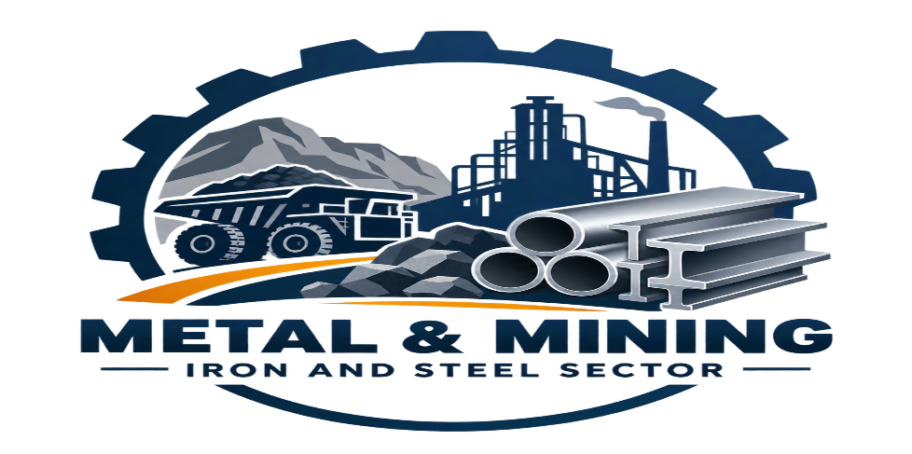
Introduction
India has a strong position in the metals and mining industry, supported by competitive production costs, abundant mineral resources, and its strategic location for exports to fast-growing Asian markets. The sector provides essential raw materials to construction, infrastructure, automobiles, manufacturing, and power industries, making it important for overall economic and industrial growth.
Key Industry Highlights
- India produced 168.4 MT of crude steel and 160.9 MT of finished steel in FY26.
- India is the second-largest aluminium producer globally.
- India is expected to reach around 330 MT of steel production capacity by 2030, exceeding the earlier 300 MT target.
- Iron ore production remained strong, with 156.6 MT produced during April–October FY26.
- The industry contributes to GDP growth, employment, exports, and foreign exchange earnings.
Major Market Drivers
- Infrastructure & Urbanisation: Government infrastructure spending and urban development are increasing demand for steel and aluminium.
- Clean Energy: Electric vehicles and renewable energy projects are increasing demand for copper and other critical minerals.
- Government Support: Policies such as the National Critical Mineral Mission and PLI schemes support domestic production and reduce import dependence.
- Capacity Expansion: Major companies are investing in new and expanded mining, steel, and metal-processing facilities.
Key Segments
- Iron & Steel: Major input for construction, infrastructure, automobiles, and manufacturing.
- Aluminium & Base Metals: Important for transportation, electrical equipment, packaging, and industrial applications.
- Critical Minerals: Lithium, nickel, cobalt, and rare earth elements are becoming increasingly important due to the clean-energy transition.
Challenges & Outlook
- Environmental regulations are increasing compliance and sustainability requirements.
- Commodity price volatility can affect company revenues, profits, and investment decisions.
- Continued government support, infrastructure development, and investments indicate significant long-term growth opportunities for India's metals and mining sector.
Overall: The Indian metals and mining sector is supported by strong domestic demand, infrastructure development, clean-energy requirements, government policies, and capacity expansion, while commodity-price volatility and environmental compliance remain key challenges.

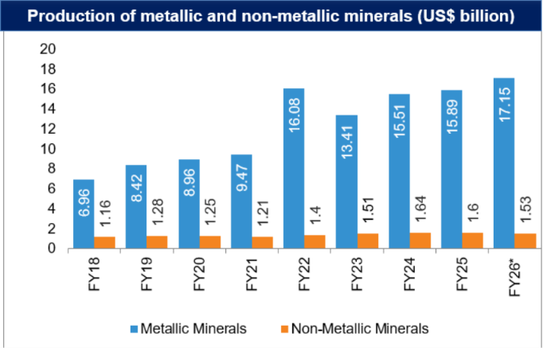

Source from IBEF Website https://www.ibef.org

3) COMPANY ANALYSIS
I) JSW Steel Limited
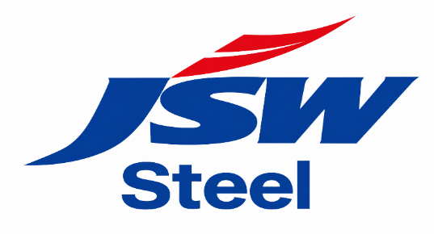
JSW Steel Limited is an Indian multinational steel company based in Mumbai and is a flagship company of the JSW Group.Headquartered in Mumbai, Maharashtra, JSW Steel is India's leading private sector integrated steel producer and part of the diversified JSW Group. With a consolidated crude steel capacity of around 37.9 MTPA, it serves global markets across 140+ countries, driving innovations in automotive, construction, and heavy engineering
Company Overview & Leadership
- Parent Group: JSW Group
- Founder & Head: Sajjan Jindal (Chairman & Managing Director)
- Headquarters: Mumbai, Maharashtra, India
- Global Ranking: Among the top 10 global steel producers, recognized frequently as a World Steel Association Sustainability Champion
Key Manufacturing Facilities
- Vijayanagar Works (Karnataka): Flagship and India's largest single-location integrated steel manufacturing facility.
- Dolvi Works (Maharashtra): Features advanced hot strip mill capabilities and strategic coastal logistics.
- Salem Works (Tamil Nadu): Specialized in special steel and alloy products.
- Bhushan Power & Steel (BPSL) & JSW Uttam Galva: Key acquisitions and subsidiaries enhancing national footprint.
- Global Presence: Operates manufacturing and processing units across the United States and Europe.
Strategic Partnerships & Joint Ventures
- JSW JFE Steel Ltd: A 50:50 venture with Japan's JFE Steel for high-grade value-added automotive and engineering steel.
- JSW Severfield Structures Ltd: Delivers advanced structural steel solutions.
- JSW MI Steel Service Center: A partnership with Marubeni-Itochu Steel for precision steel processing.
1. History of JSW Steel
JSW Steel's history began in 1982, when the Jindal Group acquired Piramal Steel Limited, which operated a mini steel plant at Tarapur, Maharashtra. The company was renamed Jindal Iron and Steel Company (JISCO). In the same year, the group established its first steel plant at Vasind near Mumbai. In 1994, Jindal Vijayanagar Steel Limited (JVSL) was established at Toranagallu in Karnataka, an important iron ore region. The company later expanded its manufacturing operations and established a steel plant at Salem. In 2005, JISCO and JVSL merged to form JSW Steel Limited. This merger became an important step in the development and expansion of JSW Steel as a major steel manufacturer.
2. Operations :- JSW Steel is engaged mainly in the manufacturing and sale of steel and related products. Its products include:
- Long rolled products
- Galvanised coils and sheets
- Cold-rolled coils and sheets
- Plates and pipes
- Other steel products
- Iron ore
According to the information provided, around 98% of the company's revenue comes from steel and related products. Approximately 70% of revenue is generated from India, while the remaining 30% comes from overseas operations.
The company has historically focused strongly on flat steel products. It also sends a significant portion of its flat products to downstream facilities for value-added processes such as galvanising, coating and tinning.
3. Major Manufacturing Plants
Plant | Location | Major Features
Vijayanagar Works | Karnataka | Flagship integrated steel plant and major production facility
Dolvi Works | Maharashtra | Integrated steel plant using advanced steel-making technology
Sambalpur Works | Odisha | Integrated steel plant acquired from Bhushan Power & Steel
Salav Works | Maharashtra | Steel manufacturing facility near Dolvi
Kalmeshwar Works | Maharashtra | Produces galvanised, Galvalume and pre-painted steel
Tarapur Works | Maharashtra | Major coated steel manufacturing facility
Vasind Works | Maharashtra | Cold rolling, galvanising and colour coating
Salem Works | Tamil Nadu | Special alloy steel manufacturing
Among these, Vijayanagar Works is the flagship facility and is described as the largest single-location steel manufacturing unit in India.
4. Expansion and Growth
JSW Steel has expanded its business through both organic expansion and acquisitions.
The company has increased its steel production capacity through expansion of existing plants and acquisition of other steel companies. The Vijayanagar plant has been undergoing major expansion, including additional blast furnace, steel melt shops and hot strip mill facilities.
The company's growth strategy has focused on:
- Increasing steel production capacity
- Expanding value-added steel products
- Strengthening its presence in India and international markets
- Acquiring existing steel assets
- Increasing control over raw materials such as iron ore and coking coal
- Developing sustainable and green steel production
5. Major Mergers and Acquisitions
JSW Steel has made several important acquisitions as part of its expansion strategy.Some major transactions include:
- 2014: Acquisition of Welspun Maxsteel Limited for around ₹1,000 crore.
- 2018: JSW Steel Italy acquired major interests in Aferpi S.p.A and related companies in Italy.
- 2019: Acquisition of Bhushan Power & Steel, adding an integrated steel plant at Sambalpur, Odisha.
- 2020: Acquisition of JSW Ispat Steel.
- 2021: Acquisition of the Plate and Coil Mill Division of Welspun Corp for approximately ₹848.5 crore.
- 2023: Acquisition of National Steel & Agro Industries (NSAIL) through the corporate insolvency resolution process.
- 2023: Agreement with JFE Steel for a proposed joint venture to manufacture cold-rolled grain-oriented electrical steel (CRGO) in India.
These acquisitions have helped JSW Steel expand its production capacity, product portfolio and geographical presence.
6. Mining Activities
Raw materials are very important for the steel industry. JSW Steel has therefore developed its own mining assets to support its steel production. According to the information provided, the company has:
- 13 iron ore mines
- 9 iron ore mines in Karnataka
- 4 iron ore mines in Odisha
- 3 coking coal mines
During FY 2022, the company met around 43% of its iron ore requirements from its own mines. In 2023, JSW Steel also acquired an iron ore block in the Surjagarh area of Gadchiroli, Maharashtra, through a government auction. The company has also previously acquired mining assets in countries including the United States, Chile and Mozambique.
7. Green Steel and Sustainability :- JSW Steel is also focusing on reducing the environmental impact of steel production.The company has planned the use of green hydrogen and green oxygen in steel production. It has an agreement with JSW Energy for the procurement of green hydrogen and green oxygen.
The company also plans to develop green steel production facilities and gradually reduce its dependence on traditional blast furnace-based production.
These initiatives are aimed at:
- Reducing carbon emissions
- Increasing the use of renewable energy
- Producing sustainable steel
- Generating carbon credits
- Meeting international environmental requirements
8. Vision, Mission and Values
JSW Steel Limited (“JSW”) believes in creating sustainable growth while balancing utilization of natural resources and social development in its business decisions.
It also believes in pursuing its business objectives ethically, transparently and with accountability to its stakeholders across the value chain.
JSW is committed to promote integrated responsible behaviour and value for social and environmental well-being.
JSW’s commitment to do business responsibly is built into the core values of the Company to conduct every aspect of business responsibly and sustainably.
It relies on:
- A dynamic leadership
- Adherences to core values
- A well-articulated Enterprise Risk Management framework.
- Practices that seek to sustain and enhance the long term competitive advantage of JSW with care for the society and environment

Financials and Valuations of JSW STEEL Ltd.

Income Statement (Rs) (Consolidated)
Line Item | FY24 | FY25 | FY26
Sales volume (m tonne) | 24.8 | 26.5 | 29.6
Net revenue | 1,750,060 | 1,688,240 | 1,854,700
Growth (%) | 5.5 | -3.5 | 9.9
Total Expenses | 1,467,700 | 1,459,200 | 1,556,490
EBITDA | 282,360 | 229,040 | 298,210
EBITDA/tonne (Rs./tonne) | 11,395 | 8,659 | 10,064
EBITDA margins (%) | 16.1 | 13.6 | 16.1
Depreciation | 81,720 | 93,090 | 96,010
Other income | 10,040 | 6,940 | 12,480
Interest expenses | 81,050 | 84,120 | 91,020
PBT before excep. Items | 129,630 | 58,770 | 123,660
PBT after exceptional items | 135,220 | 53,880 | 297,250
Effective tax | 44,070 | 15,860 | 37,420
PAT (before Ass. / (Mino.) | 91,450 | 38,020 | 259,830
Sh. of associate/minority | (110) | (3,240) | 27,170
Reported PAT | 88,120 | 35,040 | 223,160
Adj. PAT | 82,230 | 39,930 | 86,980

SOURCE - https://www.moneycontrol.com/india

Balance Sheet (Rs m) JSW STEEL
Line Item | FY24 | FY25 | FY26
Share capital | 3,050 | 3,050 | 3,050
Net worth | 776,690 | 794,960 | 1,000,330
Total Debt | 879,840 | 987,520 | 993,100
Minority interest | 21,070 | 21,700 | 54,220
DTL / (Assets) | 93,590 | 92,130 | 92,750
Others | 32,840 | 45,580 | 66,170
Capital employed | 1,804,030 | 1,941,890 | 2,206,770
Net tangible assets | 1,051,230 | 1,168,140 | 1,095,320
Net intangible assets | 31,810 | 31,810 | 30,320
CWIP | 292,160 | 204,780 | 218,920
Other non-current assets | 258,440 | 292,360 | 317,670
Current assets (excl. cash) | 453,630 | 433,710 | 440,250
Cash | 80,300 | 116,550 | 392,560
Bank balance | 43,210 | 74,490 | 22,510
Other current assets | 68,200 | 82,610 | 179,030
Current liabilities | 474,950 | 462,560 | 489,810
Capital deployed | 1,804,030 | 1,941,890 | 2,206,770

SOURCE - https://www.moneycontrol.com/india

Cash-flow Statement (Rs m) JSW STEEL
Line Item | FY24 | FY25 | FY26
EBITDA | 2,82,360 | 2,29,040 | 2,98,210
+ other adj. | 2,360 | 6,490 | 22,640
- Incr. / (decr.) in WC | -1,36,150 | -6,810 | -37,080
Others incl. taxes | -27,790 | -19,730 | -32,250
CF from op. activity | 1,20,780 | 2,08,990 | 2,51,520
- Capex (tang. + intang.) | -1,55,470 | -1,26,350 | -1,44,370
Free cash-flow | -34,690 | 82,640 | 1,07,150
Others | 9,090 | -43,620 | 3,31,270
CF from inv. activity | -1,46,380 | -1,69,970 | 1,86,900
- Div. (incl. buyback & taxes) | -8,220 | -17,850 | -6,850
+ Debt raised | 38,980 | 91,160 | -6,110
Others | -80,810 | -75,930 | -93,160
CF from fin. activity | -50,050 | -2,620 | -1,61,110
Closing cash balance | 80,300 | 1,16,550 | 3,92,560

SOURCE - https://www.moneycontrol.com/india

Ratio Analysis JSW STEEL
Line Item | FY24 | FY25 | FY26
EPS (Rs) | 33.6 | 16.3 | 35.6
P/E (x) | 36.8 | 75.7 | 34.8
P/BV (x) | 3.9 | 3.8 | 3.0
EV / EBITDA (x) | 13.4 | 16.7 | 12.1
RoE (%) | 12.3 | 4.5 | 24.9
RoCE (%) | 12.5 | 7.6 | 10.3
DPS (Rs) | 7.3 | 2.8 | 7.1
Dividend payout(%) | 22 | 17 | 20
Net debt / EBITDA(x) | 2.7 | 3.5 | 1.9
Inventory (days) | 78 | 75 | 64
Debtors (days) | 16 | 18 | 22
Payable (days) | 32 | 26 | 28
EBITDA margins (%) | 16.1 | 13.6 | 16.1
Net profit margins (%) | 4.7 | 2.4 | 4.7

SOURCE - https://www.moneycontrol.com/india

II ) TATA STEEL LTD.
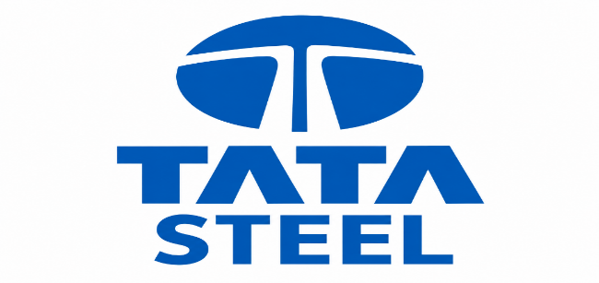
1. Company Overview
Tata Steel Limited is an Indian multinational steel company headquartered in Mumbai, Maharashtra, and is a part of the Tata Group. The company was established on 26 August 1907 as Tata Iron and Steel Company Limited (TISCO).
Tata Steel is one of India's major steel producers, with operations across India and international markets. In 2024, the company had an estimated annual crude steel capacity of 35 million tonnes and produced approximately 31.02 million tonnes of crude steel. It employed around 78,300 people worldwide and operated in 26 countries.
2. History
Tata Steel was founded by Jamsetji Nusserwanji Tata and established under the leadership of Sir Dorabji Tata in 1907.
The company started pig iron production in 1911 and began steel production in 1912 at Jamshedpur. Over the years, Tata Steel expanded its production capacity through modernization and investment in new technologies.
Important milestones include:
- 1907: Tata Iron and Steel Company (TISCO) established.
- 1911: Started pig iron production.
- 1912: Started steel production.
- 1951–1958: Major modernization and expansion programme.
- 2005: TISCO renamed Tata Steel Limited.
- 2007: Acquired Corus Group, significantly expanding its international presence.
- 2022: Seven Tata Group metal companies were amalgamated with Tata Steel.
- 2025: Expansion of the Kalinganagar facility increased its annual capacity from 3 MTPA to 8 MTPA.
3. Major Acquisitions
Acquisitions have played an important role in Tata Steel's growth and international expansion.
Major acquisitions include:
Year | Acquisition | Importance
2004 | NatSteel'steel-making operations | Expanded presence in Southeast Asia
2005 | Millennium Steel, Thailand | Strengthened Southeast Asian operations
2007 | Corus Group | Major international expansion into Europe
2017–18 | Bhushan Steel | Strengthened Indian steel manufacturing capacity
2019 | Usha Martin's steel division | Added specialty steel, iron ore and coal assets
2022 | Neelachal Ispat Nigam Ltd. | Expanded steel operations in Odisha

The Corus acquisition in 2007 was particularly significant because it substantially increased Tata Steel's international scale and made it one of the world's major steel producers at that time.
4. Amalgamation of Tata Group Metal Companies
In 2022, Tata Steel completed the amalgamation of seven Tata Group metal companies.
These included:
- Tata Steel Long Products Limited
- The Tinplate Company of India Limited
- Tata Metaliks Limited
- TRF Limited
- Indian Steel & Wire Products Limited
- Tata Steel Mining Limited
- S & T Mining Company Limited
The amalgamation helped consolidate the Tata Group's metal and steel businesses under Tata Steel.
5. Joint Ventures and Strategic Partnerships
Tata Steel has also expanded its capabilities through joint ventures and partnerships.
Important examples include:
- Tata BlueScope Steel – established with Australia's BlueScope Steel for pre-engineered steel products.
- Jamshedpur Continuous Annealing and Processing Company (JCAPCPL) – established with Nippon Steel to manufacture continuous annealed products mainly for the automotive industry.
These partnerships helped Tata Steel develop value-added and specialized steel products.
6. Major Manufacturing Operations
Tata Steel has major steel manufacturing operations in India as well as overseas.
The Jamshedpur plant is one of the company's historically important manufacturing facilities. The Kalinganagar plant in Odisha is another major modern facility. In 2025, its annual capacity was expanded from 3 MTPA to 8 MTPA after an investment of approximately ₹27,000 crore.
The Kalinganagar plant has also been recognized for the use of advanced manufacturing technologies.
7. European Operations and Challenges
Following the acquisition of Corus, Tata Steel developed a significant presence in Europe. However, its European operations faced several challenges, including:
- Excess steel production capacity in the European market
- Competition from low-cost imports
- Labour-related issues
- Increasing environmental and decarbonization requirements
- Rising operating costs
Tata Steel subsequently restructured its European operations, including separating its UK and Netherlands businesses.
In 2024, Tata Steel UK announced a restructuring at the Port Talbot steelworks, including significant job reductions, as part of changes to its operations.
8. Sustainability and Technology
Sustainability and technological modernization have become important areas for Tata Steel.
The company has invested in modern manufacturing technologies and has focused on reducing the environmental impact of steel production.
The Kalinganagar plant's inclusion in the World Economic Forum's Global Lighthouse Network reflects the use of advanced manufacturing technologies.
The company is also working on the transition towards lower-carbon steel production, particularly in its European operations.
9.Vision and mission
We aspire to be the global steel industry benchmark for Value Creation and Corporate Citizenship
Mission
Tata Steel India
We will be the most profitable and sustainable steel company in India through excellence in project execution, innovation, customer centricity and giving back to society

Financials and Valuations Of TATA STEEL. Ltd.

Income Statement (Consolidated) TATA STEEL
Income Statement (Consolidated) | FY24 (INR b) | FY25 (INR b) | FY26 (INR b)
Net Sales | 2,292 | 2,185 | 2,321
Change (%) | (5.8) | (4.6) | 6.2
EBITDA | 223 | 259 | 344
% of Net Sales | 9.7 | 11.9 | 14.8
Depn. & Amortization | 99 | 104 | 120
EBIT | 124 | 155 | 224
Finance cost | 75 | 73 | 72
Other income | 18 | 15 | 14
PBT before EO | 67 | 97 | 166
EO income | (78) | (15) | (10)
Share of asso. | (1) | 2 | 4
PBT after EO | (11) | 84 | 160
Tax | 38 | 52 | 51
Rate (%) | (328.0) | 62.3 | 31.8
PAT (Before MI & asso.) | (49) | 32 | 109
Minority interest P/L | (5) | (2) | 1
Reported PAT (After MI & asso.) | (44) | 34 | 108
Adjusted PAT | 30 | 42 | 112
Change (%) | (65.7) | 41.4 | 167.0

SOURCE - https://www.moneycontrol.com/india

Balance Sheet (Consolidated) TATA STEEL
Balance Sheet (ConsoliPdated) | FY24 (INR b) | FY25 (INR b) | FY26 (INR b)
Share Capital | 12 | 12 | 12
Reserves | 908 | 899 | 1,009
Net Worth | 920 | 912 | 1,022
Minority Interest | 4 | 2 | 16
Total Loans | 871 | 948 | 924
Deferred Tax Liability | 130 | 144 | 153
Capital Employed | 1,925 | 2,006 | 2,115
Other Liabilities | 135 | 141 | 152
Total Liabilities | 2,060 | 2,147 | 2,267
Gross Block | 2,167 | 2,288 | 2,654
Less: Accum. Deprn. | 931 | 1,036 | 1,155
Net Fixed Assets | 1,235 | 1,252 | 1,499
Capital WIP | 334 | 406 | 275
Goodwill & Others | 263 | 267 | 310
Investments | 55 | 58 | 61
Other Assets | 142 | 127 | 142
Curr. Assets | 705 | 684 | 725
Inventory | 492 | 446 | 472
Account Receivables | 63 | 53 | 49
Cash & liquid investment | 87 | 116 | 101
Others | 64 | 69 | 103
Curr. Liability & Prov. | 674 | 647 | 745
Account Payables | 302 | 293 | 348
Provisions & Others | 372 | 354 | 397
Net Current Assets | 31 | 37 | (20)
Appl. of Funds | 2,060 | 2,147 | 2,267

SOURCE - https://www.moneycontrol.com/india

Ratios (Consolidated) TATA STEEL
Ratios (Consolidated) | FY24 | FY25 | FY26
Basic (INR)
EPS | 2.4 | 3.4 | 9.0
Cash EPS | 10.3 | 11.7 | 18.6
BVPS | 73.8 | 73.1 | 81.9
DPS | 3.6 | 3.6 | 4.0
Payout (%) | 151.4 | 107.0 | 44.5
Valuation (x)
P/E | 53.2 | 45.8 | 18.9
Cash P/E | 12.3 | 13.2 | 9.2
P/BV | 1.7 | 2.1 | 2.1
EV/Sales | 1.0 | 1.3 | 1.3
EV/EBITDA | 10.6 | 10.6 | 8.6
Dividend Yield (%) | 2.8 | 2.3 | 2.4
Return Ratios (%)
RoE | 3.0 | 4.6 | 11.6
RoCE (pre-tax) | 7.2 | 8.7 | 11.6
RoIC (pre-tax) | 2.8 | 7.8 | 12.3
Working Capital Ratios
Debtor (Days) | 11 | 9 | 8
Inventory (Days) | 90 | 86 | 86
Payables (Days) | 60 | 56 | 59
Leverage Ratio (x)

SOURCE - https://www.moneycontrol.com/india

III ) HINDALCO INDUSTRIES LTD.

1. Company Overview
Hindalco Industries Limited is an Indian multinational company engaged mainly in the aluminium and copper manufacturing business. It is a subsidiary of the Aditya Birla Group and is headquartered in Mumbai, Maharashtra.
The company is involved in aluminium production, alumina refining, aluminium rolling and recycling, as well as copper-related operations. Through its international subsidiary Novelis, Hindalco has a major presence in the global aluminium industry.
2. History
Hindalco was established in 1958 by the Aditya Birla Group under the name Hindustan Aluminium Corporation Limited.
In 1962, the company started aluminium and alumina production at Renukoot, Uttar Pradesh, with an initial capacity of approximately:
- 20,000 tonnes per year of aluminium
- 40,000 tonnes per year of alumina
In 1989, the company was restructured and renamed Hindalco Industries Limited.
Since then, Hindalco has expanded through acquisitions, new manufacturing facilities and international operations.
3. Core Business Operations
Hindalco's major business activities include:
- Aluminium production
- Alumina refining
- Aluminium smelting
- Rolled aluminium products
- Aluminium recycling
- Copper manufacturing
- Specialised and value-added aluminium products
The company's operations cover a significant part of the aluminium value chain, from raw materials and alumina to aluminium production and downstream products.
4. Novelis Acquisition
One of the most important events in Hindalco's history was the acquisition of Novelis Inc. in 2007.
Hindalco entered into an agreement in February 2007 to acquire Novelis for approximately US$6 billion, and the transaction was completed in May 2007.
Novelis was already a major global producer of rolled aluminium products and an important aluminium recycler.
The acquisition helped Hindalco:
- Establish a strong global presence
- Enter the international rolled-aluminium market
- Expand its downstream aluminium business
- Access advanced technologies and global customers
- Strengthen its position in the value-added aluminium industry
Novelis continues to operate as a subsidiary of Hindalco.
5. Other Major Acquisitions
Hindalco has used acquisitions to strengthen its raw-material base and expand its product portfolio.
Important acquisitions include:
Year | Acquisition | Importance
2000 | Controlling stake in Indian Aluminium Company (Indal) | Strengthened India's aluminium operations
2007 | Utkal Alumina project interest from Alcan | Strengthened alumina resources
2007 | Novelis | Major international expansion and downstream aluminium business
2020 | Aleris Corporation through Novelis | Expanded high-end aluminium rolled products and aerospace presence
2024 | 26% stake in Ayana Renewable Power Four | Supports renewable power supply for aluminium operations

The acquisition of Aleris Corporation in 2020 strengthened Novelis' position in high-value aluminium applications, including the aerospace sector.
6. Power Infrastructure
Aluminium production is highly energy-intensive. Therefore, captive power generation is an important part of Hindalco's operations.
The company has captive power facilities associated with its manufacturing operations, including:
- Renusagar Power Plant – Uttar Pradesh
- Hirakud Captive Power Plant – Odisha
- Utkal Alumina Captive Power Plant – Odisha
- Aditya Captive Power Plant – Odisha
- Mahan power facility – Madhya Pradesh
These power facilities support Hindalco's aluminium smelters and alumina refining operations.
The company's investment in captive power helps support the continuous energy requirements of aluminium manufacturing.
7. Renewable Energy Initiatives
Hindalco is also increasing its focus on renewable energy.
In 2024, the company announced the acquisition of a 26% stake in Ayana Renewable Power Four Private Limited. The arrangement is intended to support the supply of approximately 100 MW of renewable energy to Hindalco's smelter operations in Odisha.
This initiative is relevant to the company's long-term strategy of improving energy efficiency and increasing the use of renewable energy.
8. Recent Strategic Development
In February 2026, Hindalco signed a Memorandum of Understanding with Embraer, a Brazilian aerospace company, to explore potential sources for aerospace-grade aluminium manufacturing in India.
This indicates Hindalco's interest in expanding into high-value and specialised aluminium applications.
9. Listing and Shareholding
Hindalco Industries Limited is listed on India's major stock exchanges:
- BSE
- National Stock Exchange (NSE)
Its shares are also included in major Indian market indices according to the information provided.
As of 31 March 2022, the Aditya Birla Group promoters held approximately 34.64% of the company's equity shares. More than 408,000 individual shareholders collectively held approximately 9% of the shares.

Financials and Valuations Of Hindalco Industries Ltd.
Consolidated Income Statement (INR b) of HINDALCO
Y/E March | 2024 | 2025 | 2026
Net sales | 2,159.6 | 2,385.0 | 2,749.4
Change (%) | (3.2) | 10.4 | 15.3
Total Expenses | 1,920.9 | 2,066.9 | 2,400.6
EBITDA | 238.7 | 318.1 | 348.8
% of Net Sales | 11.1 | 13.3 | 12.7
Depn. & Amortization | 75.2 | 78.8 | 88.3
EBIT | 163.5 | 239.2 | 260.5
Net Interest | 38.6 | 34.2 | 34.8
Other income | 15.0 | 27.1 | 28.9
PBT before EO | 139.9 | 232.1 | 254.6
EO income (exp) | 0.2 | (8.8) | (69.6)
PBT after EO | 140.1 | 223.3 | 185.0
Current tax | 30.1 | 63.5 | 75.3
Deferred tax (net) | 8.5 | (0.2) | (24.3)
Tax | 38.6 | 63.4 | 51.1
Rate (%) | 27.5 | 28.4 | 27.6
PAT (before MI and Sh. of Aso.) | 101.5 | 160.0 | 134.0
Minority interests and disc. Operations | - | - | -
Share of asso. | 0.0 | 0.0 | (0.0)
Reported PAT (after MI and Sh. of Aso.) | 101.6 | 160.0 | 133.9
Adjusted PAT | 101.3 | 166.2 | 185.4
Change (%) | 0.8 | 63.9 | 11.6

SOURCE - https://www.moneycontrol.com/india

BALANCE SHEET (Figures in INR b). of HINDALCO
Balance Sheet (INR b) | 2024 | 2025 | 2026
Share Capital | 2.2 | 2.2 | 2.2
Reserves | 1,059.2 | 1,234.9 | 1,363.6
Net Worth | 1,061.5 | 1,237.1 | 1,365.8
Minority Interest | 0.1 | 0.1 | 0.1
Total Loans | 545.0 | 619.3 | 966.6
Deferred Tax Liability | 81.6 | 87.8 | 45.7
Capital Employed | 1,688.2 | 1,944.3 | 2,378.2
Gross Block | 1,650.8 | 1,771.0 | 1,967.5
Less: Accum. Deprn. | 793.5 | 872.3 | 960.6
Net Fixed Assets | 857.4 | 898.7 | 1,007.0
Goodwill | 260.8 | 266.8 | 295.5
Capital WIP | 148.7 | 274.0 | 495.3
Investments | 121.7 | 136.3 | 170.7
Working capital Assets | 918.7 | 1,067.2 | 1,478.3
Inventory | 408.1 | 488.0 | 755.2
Account Receivables | 164.0 | 198.3 | 272.2
Cash and Bank Balance | 177.1 | 213.8 | 226.9
Others (incl. LT) | 169.5 | 167.1 | 224.0
Working capital liability | 619.1 | 698.7 | 1,068.6
Account Payables | 392.9 | 427.0 | 619.9
Others (incl. LT) | 226.2 | 271.7 | 448.8
Net Working Capital | 299.7 | 368.5 | 409.7
Appl. of Funds | 1,688.2 | 1,944.3 | 2,378.2

SOURCE - https://www.moneycontrol.com/india

CASH FLOW STATEMENT OF HINDALCO figures in INR b

Line Item / Year ending March | 2024 | 2025 | 2026
EBITDA | 238.7 | 318.1 | 348.8
Others | 9.2 | 3.9 | (39.2)
tax paid | (26.8) | (54.7) | (64.8)
Change in WC | 19.4 | (23.2) | (142.4)
CF from Op. Activity | 240.6 | 244.1 | 102.5
(Inc)/Dec in FA + CWIP | (157.3) | (206.5) | (301.0)
Free Cash Flow to firm | 83.3 | 37.6 | (198.5)
(Pur)/Sale of Inv. & yield | (3.7) | 32.0 | 48.4
Others & M&A | 18.3 | (72.9) | (13.3)
CF from Inv. Activity | (142.8) | (247.4) | (265.8)
Equity raised/(repaid) | (1.2) | (1.0) | (1.2)
Debt raised/(repaid) | (61.4) | 48.4 | 134.1
Interest | (38.9) | (57.7) | 79.1
Dividend (incl. tax) | (6.7) | (7.8) | (11.1)
CF from Fin. Activity | (108.2) | (18.2) | 200.9
(Inc)/Dec in Cash | (10.4) | (21.5) | 37.5
Add: Opening Balance | 128.4 | 118.2 | 98.1
Changes in forex on CF | 0.2 | 1.4 | 7.9
Closing cash Balance | 118.2 | 98.1 | 143.5
Bank balance (inc. O/D adj.) | 58.9 | 115.7 | 83.4
Closing Balance (incl. bank balance) | 177.1 | 213.8 | 226.9

SOURCE - https://www.moneycontrol.com/india

KEY RATIOS OF HINDALCO Industries
Financial Ratios | 2024 | 2025 | 2026
Basic (INR)
EPS | 45.7 | 74.8 | 83.5
Cash EPS | 79.6 | 107.6 | 100.1
BV/Share (adj.) | 360.7 | 437.1 | 482.1
DPS | 3.0 | 5.0 | 5.0
Payout (%) | 6.6 | 6.7 | 6.0
Valuation (x)
P/E | 23.2 | 14.2 | 12.7
Cash P/E | 13.3 | 9.9 | 10.6
P/BV | 2.9 | 2.4 | 2.2
EV/Sales | 1.3 | 1.2 | 1.1
EV/EBITDA | 11.4 | 8.7 | 8.9
Dividend Yield (%) | 0.3 | 0.5 | 0.5
Return Ratios (%)
EBITDA Margins (%) | 11.1 | 13.3 | 12.7
Net Profit Margins (%) | 4.7 | 7.0 | 6.7
RoE | 13.6 | 18.8 | 18.2
RoCE (pre-tax) | 10.8 | 14.7 | 13.4
RoIC (pre-tax) | 14.6 | 18.7 | 18.6
Working Capital Ratios
Fixed AssetTurnover (x) | 1.3 | 1.3 | 1.4
Asset Turnover (x) | 1.3 | 1.2 | 1.2
Debtor (Days) | 28 | 28 | 28
Inventory (Days) | 69 | 69 | 69
Payable (Days) | 66 | 66 | 66
Leverage Ratio (x)
Current Ratio | 1.5 | 1.5 | 1.4
Interest Cover Ratio | 4.2 | 7.0 | 7.5
Debt/Equity | 0.5 | 0.5 | 0.7

SOURCE - https://www.moneycontrol.com/india/

CHAPTER 6 :- COMPARATIVE RATIO ANALYSIS & INTERPRETATION

MINING SECTOR FINANCIAL PERFORMANCE OF JSW STEEL, TATA STEEL .LTD & HINDALCO INDUSTRIES .

1. NET PROFIT MARGIN
Net Profit Margin is a direct measure of a company's profitability. It represents the percentage of revenue that translates into net profit after all expenses, including taxes and interest, have been accounted for.
Formula: NET PROFIT / NET SALES X 100
JSW Steel :-
- 2024: 82,230 / 1,750,060 = 4.70%
- 2025: 39,930 / 1,688,240 = 2.37%
- 2026: 86,980 / 1,854,700 = 4.69%
Tata Steel :-
- 2024: 30 / 2,292 = 1.31%
- 2025: 42 / 2,185 = 1.92%
- 2026: 112 / 2,321 = 4.83%
Hindalco :-
- 2024 = 101.3 / 2,159.6 × 100 = 4.69%
- 2025 = 166.2 / 2,385.0 × 100 = 6.97%
- 2026 = 185.4 / 2,749.4 × 100 = 6.74%

Mining Sector Company | 2024 | 2025 | 2026
JSW Steel | 4.70 | 2.37 | 4.69
Tata Steel | 1.31 | 1.92 | 4.83
Hindalco | 4.7 | 6.97 | 6.74
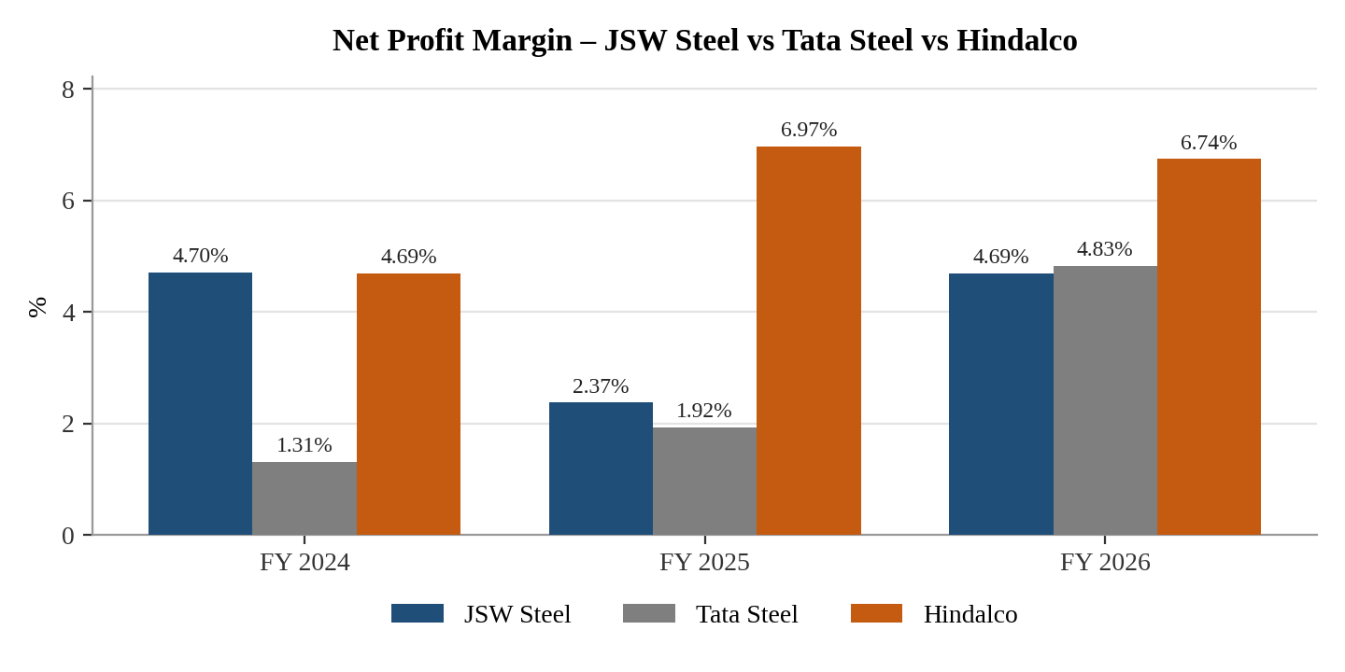

Interpretation :
JSW Steel: Margin decreased from 4.70% to 2.37% in 2025 and recovered to 4.69% in 2026. This indicates recovery in profitability in 2026.
Tata Steel: Margin increased consistently from 1.31% to 1.92% and then 4.83%, showing improvement in profit generation.
Hindalco: Margin improved strongly in 2025 but declined slightly in 2026 from 6.97% to 6.74%. Profitability nevertheless remained above 2024.

2. RETURN ON CAPITAL EMPLOYED (ROCE)
Return on Capital Employed (ROCE) is a financial metric that measures the profitability of a company in relation to its overall capital, which includes both equity AND debt structures.
Formula: NET INCOME / CAPITAL EMPLOYED × 100
JSW Steel :A
- 2024: 200,640 / 1,804,030 × 100 = 11.12%
- 2025: 135,950 / 1,941,890 × 100 = 7.00%
- 2026: 202,200 / 2,206,770 × 100 = 9.16%

Tata Steel :
- 2024: 2292 / 318.33 = 7.20%
- 2025: 2185 / 251.14 = 8.70%
- 2026: 2321 / 200.00 = 11.60%
Hindalco :
- 2024 : 2159 / 199.90 = 10.8%
- 2025 : 2385 / 162.24 = 14.7%
- 2026 : 2749 / 205.14 = 13.4%
Mining Sector Company | 2024 | 2025 | 2026
JSW Steel | 11.12% | 7.0% | 11.60%
Tata Steel | 7.20 | 8.70 | 11.60
Hindalco | 10.8 % | 14.7 % | 13.4%
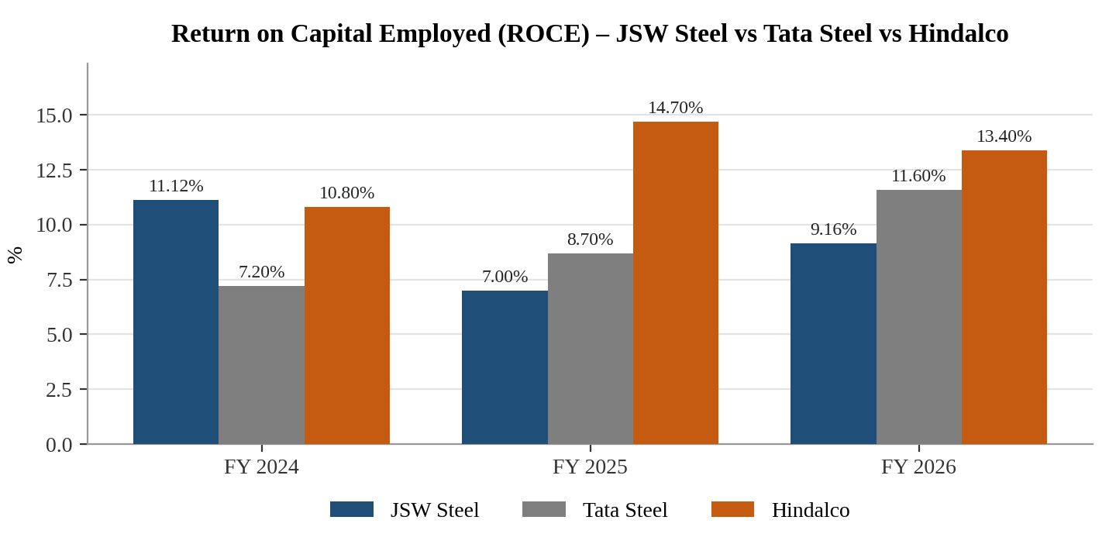
Interpretation :-
JSW Steel: decreased from 11.12% to 7.0%, then increased by11.60%.
Tata Steel: Continues increased by 7.20 to 8.70 and then increased by 11.60
Hindalco: increased by 10.8% o 14.7 % and then decreased by 13.4 %

3. RETURN ON EQUITY (ROE)
It measures the amount of profit that the company generates on the money invested by the shareholders. It also helps you understand how a company compares to other firms in the same industry and evaluate the company’s financial performance and asset valuation.
Formula: (NET INCOME / Shareholders' Equity)
JSW Steel :
- 2024: 1750 / 142.27 = 12.30%
- 2025: 1688 / 375 = 4.50%
- 2026: 1854 / 74.45 = 24.90%
Tata Steel :
- 2024: 2292 / 764 = 3.00%
- 2025: 2185 / 475 = 4.60%
- 2026: 2321 / 200 = 11.60%
Hindalco :
- 2024 : 2159.6 / 158.79 = 13.6%
- 2025 : 2385.0 / 126.86 = 18.8%
- 2026 : 2749.4 / 151.06 = 18.2%
Mining Sector Company | 2024 | 2025 | 2026
JSW Steel | 12.30 | 4.50 | 24.90
Tata Steel | 3.00 | 4.60 | 11.60
Hindalco | 13.6 | 18.8 | 18.2
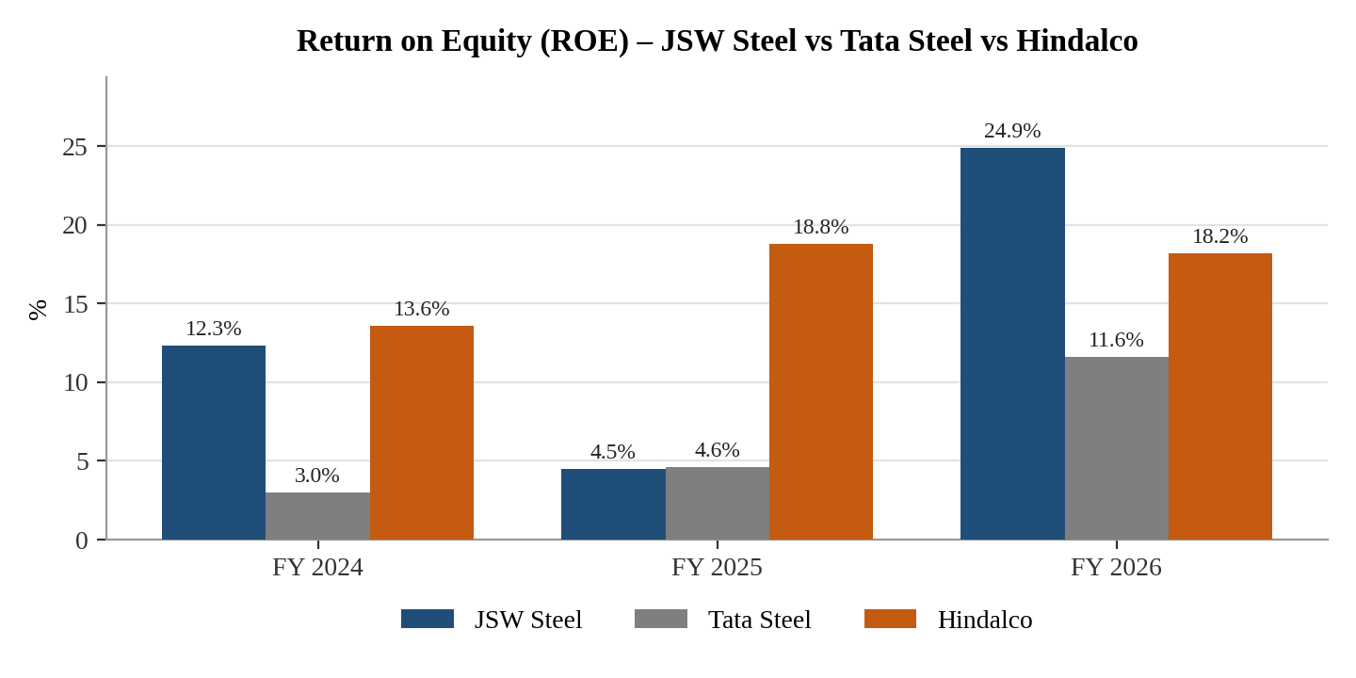
Interpretation :-
JSW Steel: ROE fell sharply in 2025 but increased strongly in 2026.
Tata Steel: ROE increased every year, showing improvement in returns generated for shareholders.
Hindalco: ROE improved from 13.6% to 18.8% and then slightly decreased to 18.2%.

4. DEBT TO EQUITY RATIO
A debt to equity ratio is determined to ascertain the soundness of the long-term financial policies of the company. The ratio indicates the extent to which the firm depends upon outsiders for its existence.
Formula: TOTAL LIABILITIES / SHAREHOLDER’S EQUITY
JSW Steel :
- 2024: 879,840 / 776,690 = 1.13x
- 2025: 987,520 / 794,960 = 1.24x
- 2026: 993,100 / 1,000,330 = 0.99x
Tata Steel :
- 2024: 871 / 920 = 0.95x
- 2025: 948 / 912 = 1.04x
- 2026: 924 / 1,022 = 0.90x
Hindalco :
- 2024 (FY25A): 640,190 / 1,237,090 = 0.5x
- 2025 (FY26A): 970,940 / 1,365,830 = 0.4x
- 2026 (FY27E): 907,105 / 1,599,515 = 0.7x

Company | 2024 | 2025 | 2026
JSW Steel | 1.13x | 1.24x | 0.99x
Tata Steel | 0.95x | 1.04x | 0.90x
Hindalco | 0.5x | 0.4x | 0.7x
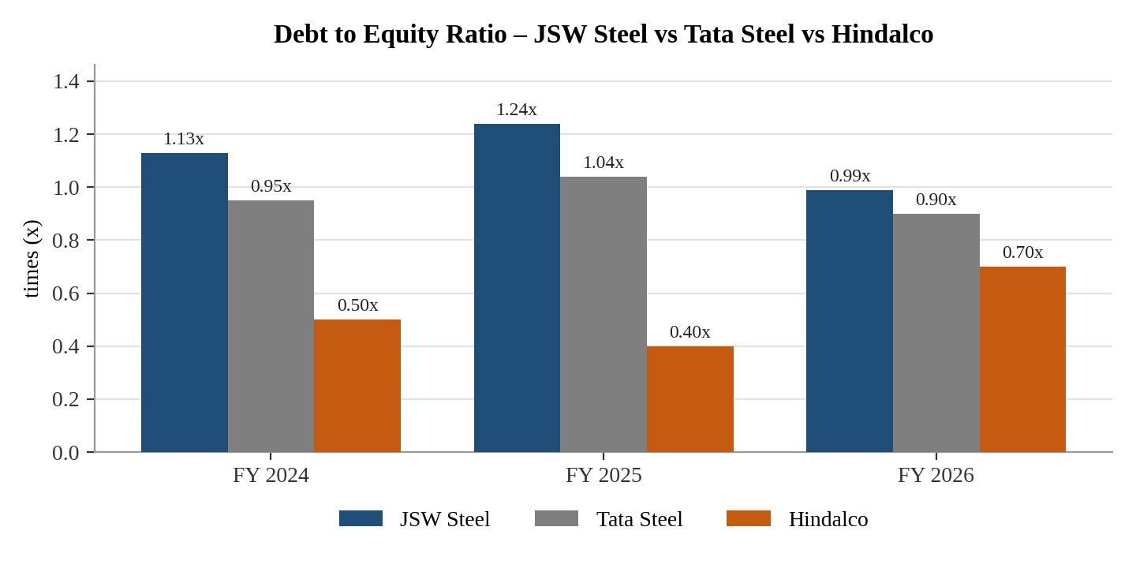
Interpretation :-
JSW Steel: Increased from 1.13x to 1.24x and then declined to 0.99x in 2026.
Tata Steel: Increased slightly in 2025 and declined to 0.90x in 2026.
Hindalco: Remained around 0.5x in 2024–25 and increased to 0.71x in 2026.
The decline in JSW and Tata in 2026 indicates lower debt relative to equity compared with 2025.

5. OPERATING RATIO
Operating Ratio measures how efficiently a company manages its day-to-day operations. A lower ratio means the company spends less to generate each dollar of revenue, which is generally a good sign. Operating Expenses include all costs related to day-to-day operations.
Formula: ( NET SALES – OPERATING PROFIT / NET SALES ) X 100
JSW Steel :
- 2024: (1,467,700 / 1,750,060 ) × 100 = 83.87%
- 2025: (1,459,200 / 1,688,240) × 100 = 86.43%
- 2026: (1,556,490 / 1,854,700) × 100 = 83.92%
Tata Steel :
- 2024: (2,292 - 223) / 2,292 × 100 = 90.27%
- 2025: (2,185 - 259) / 2,185 × 100 = 88.15%
- 2026: (2,321 - 344) / 2,321 × 100 = 85.18%
Hindalco :
- 2024 = (2,159.6 − 238.7) / 2,159.6 × 100 = 88.95%
- 2025 = (2,385.0 − 318.1) / 2,385.0 × 100 = 86.66%
- 2026 = (2,749.4 − 348.8) / 2,749.4 × 100 = 87.31%
Mining Sector Company | 2024 | 2025 | 2026
JSW Steel | 83.87 | 86.43 | 83.92
Tata Steel | 90.27 | 88.15 | 85.18
Hindalco | 88.95 | 86.66 | 87.31
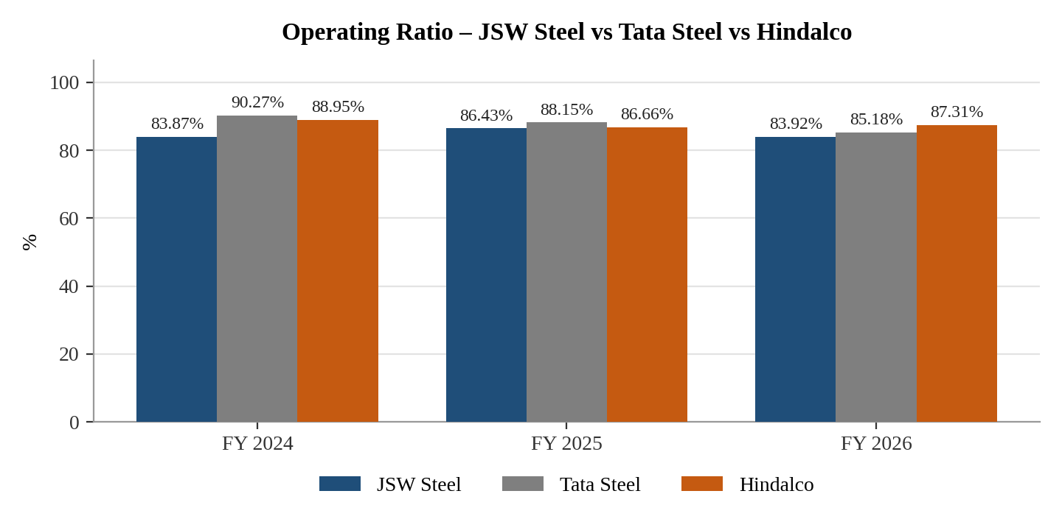
Interpretation :-
JSW Steel: Increased to 86.43% in 2025 and decreased to 83.92% in 2026, indicating improved operating efficiency in 2026.
Tata Steel: Declined continuously from 90.27% to 85.18%, indicating improvement in operating efficiency.
Hindalco: Improved in 2025 but increased slightly in 2026 to 87.31%.

6. INTEREST COVERAGE RATIO
A higher ICR indicates a company can easily cover its interest payments. A lower ICR suggests the company might struggle to meet its debt obligations. A generally accepted good ICR is 2 or higher, but it can vary by industry.
Formula: EBIT / INTEREST EXPENSE
JSW Steel :
- 2024: 200,640 / 81,050 = 2.48x
- 2025: 135,950 / 84,120 = 1.62x
- 2026: 202,200 / 91,020 = 2.22x
Tata Steel :
- 2024: 124 / 75 = 1.65x
- 2025: 155 / 73 = 2.12x
- 2026: 224 / 72 = 3.11x
Hindalco :
- 2024 (FY25A): 163.5 / 38.92 = 4.2x
- 2025 (FY26A): 239.2 / 34.17 = 7.0x
- 2026 (FY27E): 260.5 / 34.73 = 7.5x
Company Name | 2024 | 2025 | 2026
JSW Steel | 2.48x | 1.62x | 2.22x
Tata Steel | 1.65x | 2.12x | 3.11x
Hindalco | 4.2 x | 7.0 x | 7.5 x
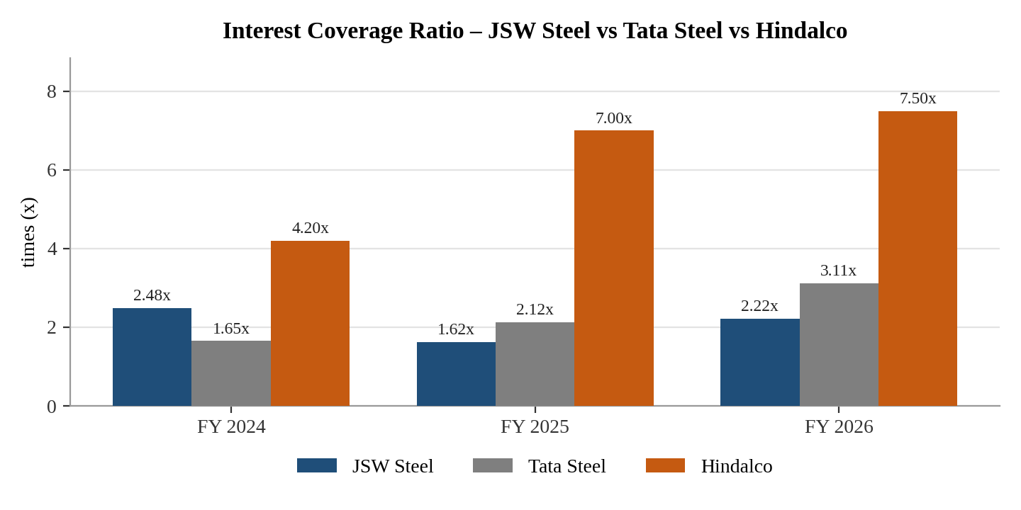
Interpretation :-
- JSW Steel: 2.48x → 1.62x → 2.22x. Coverage weakened in 2025 but recovered in 2026.
- Tata Steel: 1.65x → 2.12x → 3.11x. Continuous improvement indicates better ability to cover interest.
- Hindalco: 4.2x → 7.0x → 7.5x. Strong improvement in interest-paying capacity.
7. EARNING PER SHARE (EPS)
Earning per share are the portion of the profit which is allocated to each share of the company. It is calculated by dividing the total profit of the company by the total outstanding shares of the company.
Formula: PROFIT AFTER TAX / OUTSTANDING SHARES
JSW Steel :
- 2024:88120 / 2622.6 = 33.6
- 2025: 35040 / 2150 = 16.3
- 2026:223160 / 6269 = 35.6
Tata Steel :
- 2024: (44) /18.33 = 2.4
- 2025: 34 / 10 = 3.4
- 2026:108 / 12 = 9.0
Hindalco :
- 2024 : 101.3 / 2.21 = 45.7
- 2025 : 166.2 / 2.22 = 74.8
- 2026 : 185.4 / 2.22 = 83.5

Company | 2024 | 2025 | 2026
JSW Steel | 33.6 | 16.3 | 35.6
Tata Steel | 2.4 | 3.4 | 9.0
Hindalco | 45.7 | 74.8 | 83.5
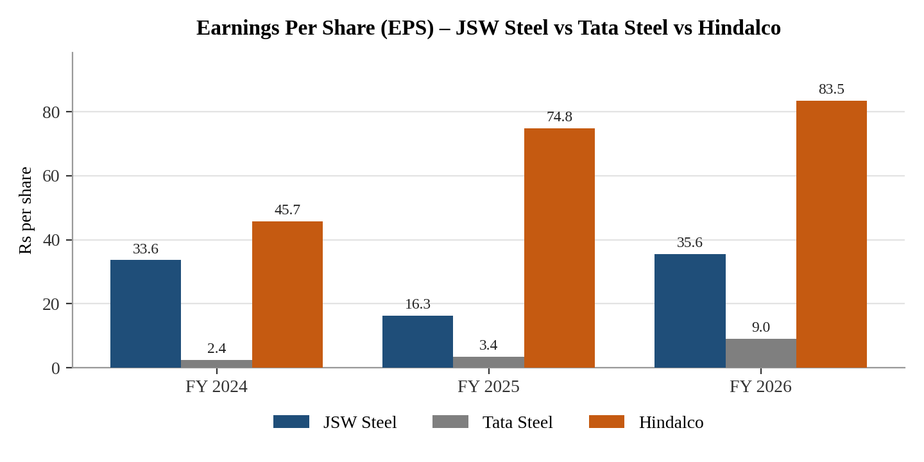
Interpretation :-
JSW EPS declined in 2025 but recovered strongly in 2026.
Tata EPS increased every year.
Hindalco EPS increased every year.
This indicates that the earnings available per share improved significantly for Tata Steel and Hindalco during the three-year period.

8. RETURN ON ASSETS (ROA)
Return on assets (ROA) is a financial metric that measures the profitability of a company in relation to its total assets. It is a key indicator of how efficiently a company is utilizing its assets to generate profits.
Formula: NET PROFIT / TOTAL ASSETS
JSW Steel :
- 2024: 82,230 / 1,804,030 = 4.56%
- 2025: 39,930 / 1,941,890 = 2.06%
- 2026: 86,980 / 2,206,770 = 3.94%
Tata Steel :
- 2024: 30 / 2,060 = 1.46%
- 2025: 42 / 2,147 = 1.96%
- 2026: 112 / 2,267 = 4.94%
Hindalco :
- 2024 = 101.3 / 2,082.77 × 100 = 4.86%
- 2025 = 166.2 / 2,527.85 × 100 = 6.57%
- 2026 = 185.4 / 2,682.577 × 100 = 6.91%
Company | 2024 | 2025 | 2026
JSW Steel | 4.56 | 2.06 | 3.94
Tata Steel | 1.46 | 1.96 | 4.94
Hindalco | 4.86 | 6.57 | 6.91
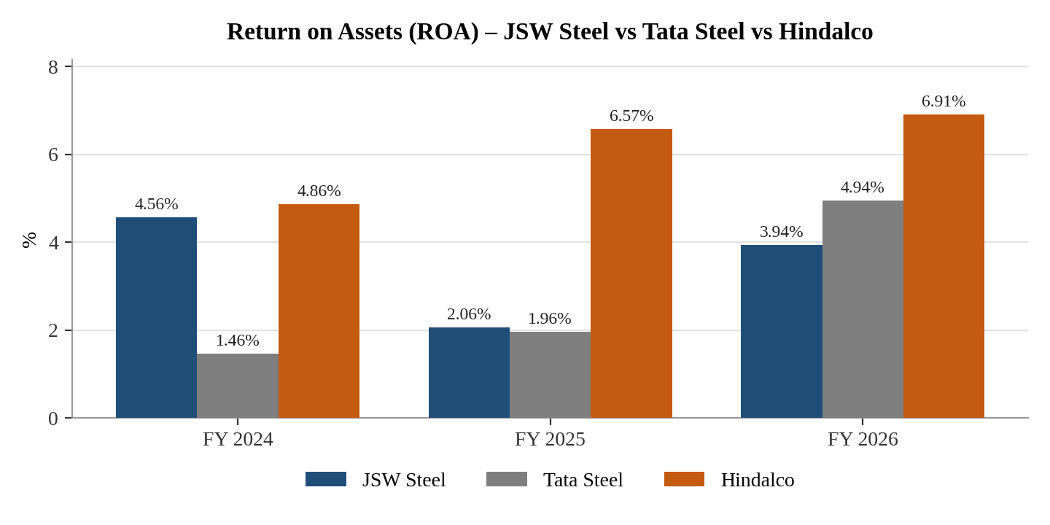
Interpretation :-
JSW Steel: 4.56% → 2.06% → 3.94%. Recovery occurred in 2026.
Tata Steel: 1.46% → 1.96% → 4.94%. Continuous improvement.
Hindalco: 4.86% → 6.57% → 6.91%. Continuous improvement.

9. CURRENT RATIO
This ratio is calculated by dividing the current assets of the company by current liabilities. Current ratio indicates the relationship between current assets (sources of repayment of liabilities) and current liabilities (financial commitments).
Formula: CURRENT ASSETS / CURRENT LIABILITIES
JSW Steel :
- 2024: 645,340 / 474,950 = 1.36x
- 2025: 707,360 / 462,560 = 1.53x
- 2026: 1,034,350 / 489,810 = 2.11x
Tata Steel :
- 2024: 705 / 674 = 1.05x
- 2025: 684 / 647 = 1.06x
- 2026: 725 / 745 = 0.97x
Hindalco :
- 2024 (FY25A): 918.7 / 619.1 = 1.5x
- 2025 (FY26A): 1067.2 / 698.7 = 1.5x
- 2026 (FY27E): 1478.3 / 1068.6 = 1.4x

Mining Sector Company | 2024 | 2025 | 2026
JSW Steel | 1.36x | 1.53x | 2.11x
Tata Steel | 1.05x | 1.06x | 0.97x
Hindalco | 1.5x | 1.5x | 1.4x
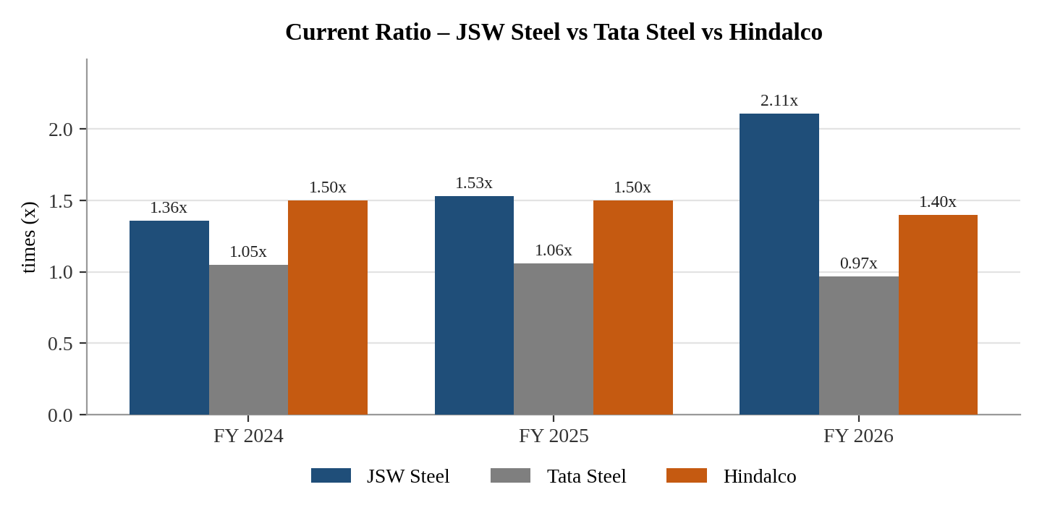
Interpretation :-
JSW Steel: The ratio increased continuously from 1.36x to 1.53x and 2.11x. This shows continuous improvement in short-term liquidity.
Tata Steel: The ratio increased slightly from 1.05x to 1.06x, but decreased to 0.97x in 2026. This shows a decline in short-term liquidity in 2026.
Hindalco: The ratio remained stable at 1.50x and then decreased to 1.40x, showing a slight decline.
Going well based on trend: JSW Steel, because its ratio increased continuously.

10. PRICE TO EARNING (P/E) RATIO
Price to Earnings Ratio (P/E Ratio) is the ratio of share price of a stock to its earnings per share (EPS). PE ratio is one of the most popular valuation metrics of stocks. It provides an indication whether a stock at its current market price is expensive or cheap.
Formula: MARKET VALUE PER SHARE / EPS
JSW Steel :
- 2024 : 1236.48 /33.6 = 36.8x
- 2025 : 1258.89 /16.63 = 75.7x
- 2026 : 1238.88 /35.6 = 34.8x
Tata Steel :
- 2024 :127.68 / 2.4 = 53.2x
- 2025 :155.72 / 3.4 = 45.8x
- 2026 :170.1 / 9.0 = 18.9x
Hindalco :
- 2024 : 1060.24 / 45.7 = 23.2x
- 2025 : 1062.16 / 74.8 = 14.2x
- 2026 : 1060.45 / 83.5 = 12.7x
Mining Sector Company | 2024 | 2025 | 2026
JSW Steel | 36.8x | 75.7x | 34.8x
Tata Steel | 53.2x | 45.8x | 18.9x
Hindalco | 23.2x | 14.2x | 12.7x
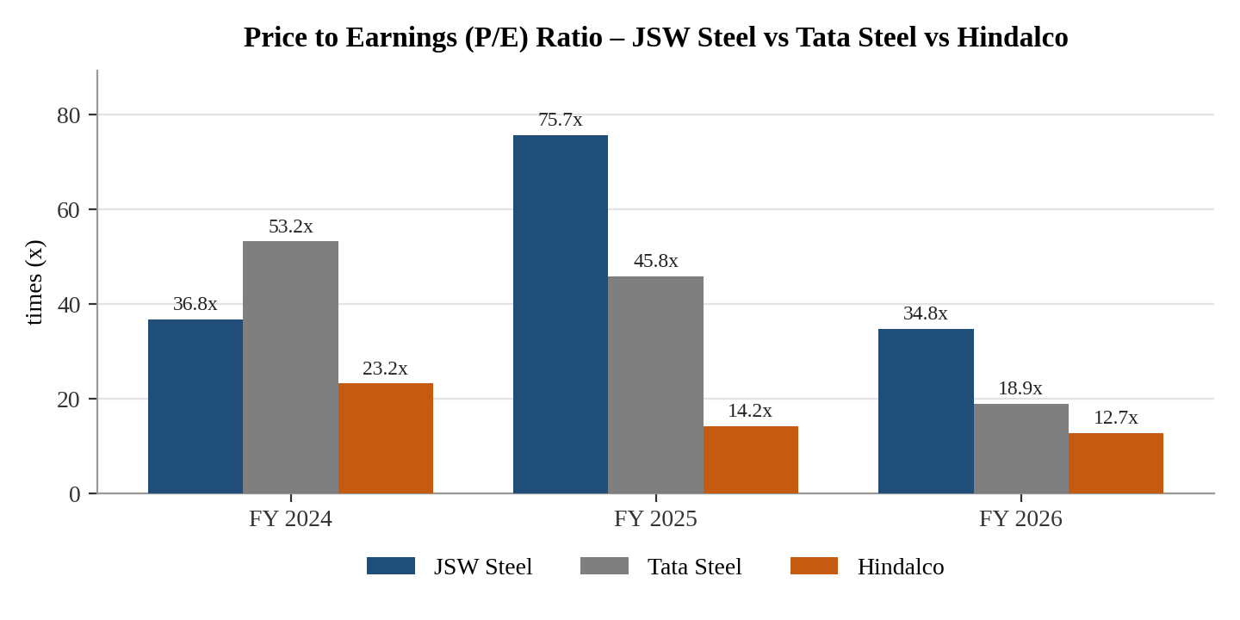
Interpretation :-
JSW Steel: P/E increased sharply from 36.8x to 75.7x, then decreased to 34.8x.
Tata Steel: P/E continuously decreased from 53.2x to 45.8x and 18.9x.
Hindalco: P/E continuously decreased from 23.2x to 14.2x and 12.7x.
Going well based on the reported downward trend: Hindalco, because its P/E decreased consistently. However, P/E by itself does not establish whether a stock is attractive; it should be considered with earnings growth and other valuation measures.

11. Sector PE Ratio Comparision with the Company PE Ratio
Example: Sector P/E vs Company P/E
Particulars | Value
Sector P/E | 25.00x
JSW Steel P/E | 34.8x
Difference | 9.00x Higher
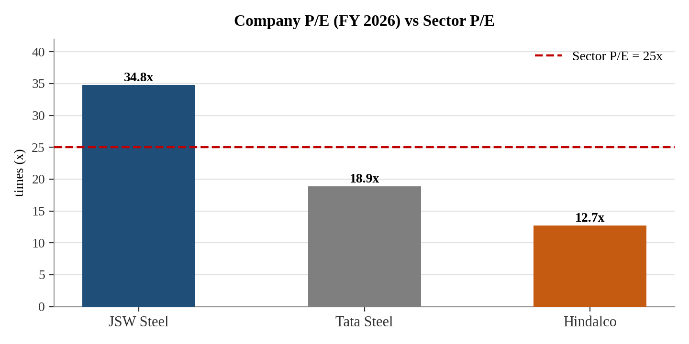
Interpretation:-
JSW Steel – P/E Comparison
JSW Steel has a P/E ratio of 34.8×, compared with the sector P/E of 25×. This means investors are paying ₹34.80 for every ₹1 of JSW Steel’s earnings, compared with ₹25 at the sector level. Therefore, JSW Steel is trading at a premium of 9.8× over the sector P/E. This may indicate that the market has higher expectations from JSW Steel regarding its future earnings and growth. However, the higher P/E also suggests that the stock may be relatively expensive compared with the sector.

Particulars | Value
Sector P/E | 25.00x
Tata Steel P/E | 18.00x
Difference | 7.00x lower
Interpretation:-
Tata Steel – P/E Comparison
Tata Steel has a P/E ratio of 18×, which is lower than the sector P/E of 25×. This means investors are paying ₹18 for every ₹1 of Tata Steel’s earnings, compared with ₹25 for the sector. Tata Steel is therefore trading at a 7× discount to the sector P/E. This may indicate that the stock is relatively undervalued compared with the sector, although the lower P/E may also reflect lower expected growth or other company-specific concerns.
Particulars | Value
Sector P/E | 25.00x
Hindalco Industries P/E | 12.7x
Difference | 13x lower
Interpretation:
Hindalco Industries – P/E Comparison
Hindalco Industries has a P/E ratio of 12.7×, compared with the sector P/E of 25×. Thus, investors are paying only ₹12.70 for every ₹1 of Hindalco’s earnings, compared with ₹25 at the sector level. Hindalco is trading at a 12.3× discount to the sector P/E. This indicates that Hindalco is relatively cheaper on an earnings basis and may offer valuation appeal, although investors should also consider the company's growth prospects, profitability, debt and business risks.
11. PRICE TO BOOK (P/B) RATIO
The price-to-book ratio (P/B ratio) is a financial ratio used to compare a company's current market value to its book value (where book value is the value of all assets minus liabilities owned by a company).
Formula: MARKET PRICE PER SHARE / BOOK VALUE PER SHARE
JSW Steel :
- 2024: ₹833.80 / ₹324.05 = 2.57x
- 2025: ₹1063.20 / 333.95 = 3.18x
- 2026: ₹1237.60 / ₹431.31 = 2.86x
Tata Steel :
- 2024:156.20 / 72.50 = 2.15x
- 2025: 153.98 / 71.92 = 2.14x
- 2026: 216.86 / 80.73 = 2.68x
Hindalco :
- 2024 : 561.85 / 479.22 = 1.17x
- 2025: 682.45 / 558.51 = 1.22x
- 2026 : 1051.20 / 616.77 = 1.70x

Mining Sector Company | 2024 | 2025 | 2026
JSW Steel | 2.57x | 3.18x | 2.86x
Tata Steel | 2.15x | 2.14x | 2.68x
Hindalco | 1.17x | 1.22x | 1.70x
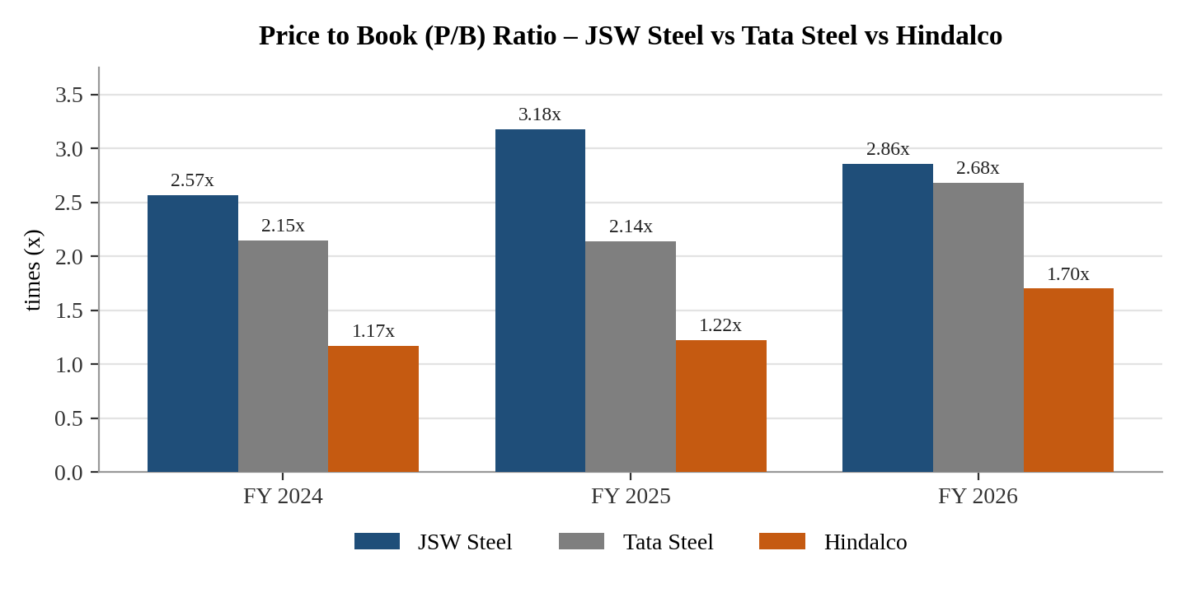
Interpretation :-
JSW Steel: P/B increased from 2.57x to 3.18x and decreased by 2.86x.
Tata Steel: P/B decreased from 2.15x to 2.14x and increased to 2.68x.
Hindalco: P/B increased from 1.17x to 1.22x and decreased to 1.70x.

12. PRICE TO EARNINGS GROWTH (PEG) RATIO
The Price to earnings growth (PEG Ratio) assesses a stock’s valuation by considering both its P/E ratio and earnings growth. A PEG ratio below 1 generally suggests that the stock may be undervalued.
Formula: P/E RATIO / ESTIMATED EPS GROWTH RATE
JSW Steel :
- 2024: 36.8x / 118.40 = 0.31x
- 2025: 75.7 / (51.48) = 1.47x
- 2026: 34.8 /127.02 = 0.27x
Tata Steel :
- 2024: 53.2 / (66.20) = 0.80x
- 2025: 45.8 / 41.67 = 1.09x
- 2026: 18.9 / 164.71 = 0.11x
Hindalco :
- 2024 :23.2x / 11.63 = 1.99x
- 2025 : 14.2 x / 63.67 = 0.22x
- 2026 : 12.7x / 0.88 = 14.43 x

Mining Sector Company | 2024 | 2025 | 2026
JSW Steel | 0.31x | 1.47x | 0.27x
Tata Steel | 0.80x | 1.09x | 0.11x
Hindalco | 1.99x | 0.22x | 14.43x
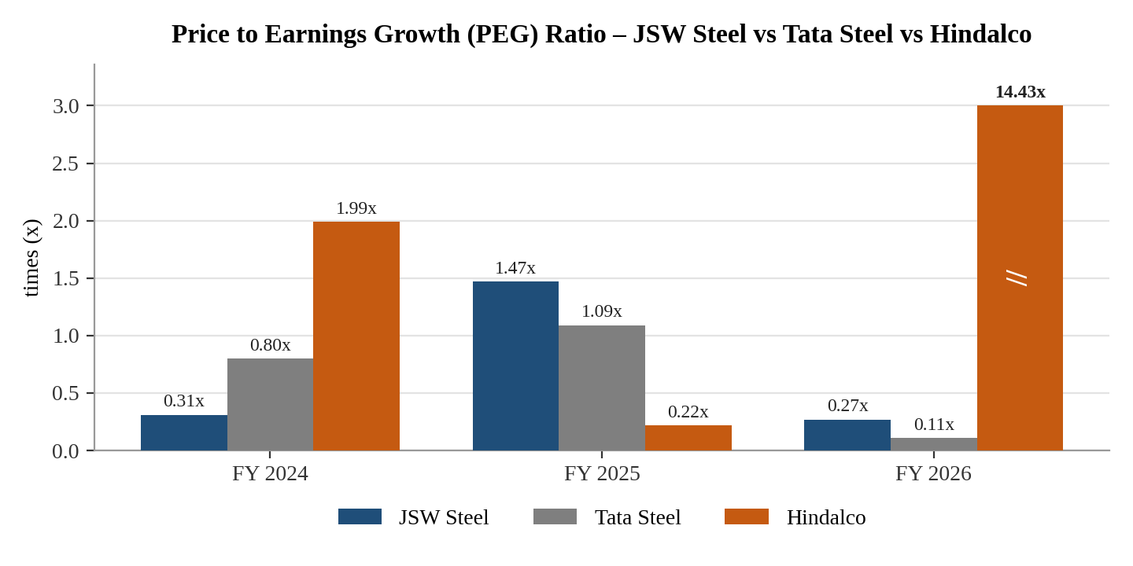
Interpretation :-
JSW Steel: PEG increased from 031x to 1.47x, then decreased to 0.27x.
Tata Steel: PEG increased from 0.80x to 1.09x and decreased to 0.11x.
Hindalco: PEG decreased from 1.99x to 0.22x, then increased to 14.43x.
13. RETURN ON INVESTMENT (ROI) RATIO
It's a financial metric that measures how much profit an investment generates relative to its cost. In simpler terms, it tells you how much you earned compared to how much you spent.
Formula: NET PROFIT / INITIAL INVESTMENT
JSW Steel :
- 2024: 200,640 / 1,804,030 = 11.12%
- 2025: 135,950 / 1,941,890 = 7.00%
- 2026: 202,200 / 2,206,770 = 9.16%
Tata Steel :
- 2024: 124 / 1,925 = 6.44%
- 2025: 155 / 2,006 = 7.73%
- 2026: 224 / 2,115 = 10.59%
Hindalco :
- 2024 : 239,240 / 2,082,770 = 14.6%
- 2025 : 260,540 / 2,527,850 = 18.7%
- 2026 : 353,373 / 2,682,577 = 18.6%
Mining Sector Company | 2024 | 2025 | 2026
JSW Steel | 11.12 | 7.00 | 9.16
Tata Steel | 6.44 | 7.73 | 10.59
Hindalco | 14.6 | 18.7 | 18.6

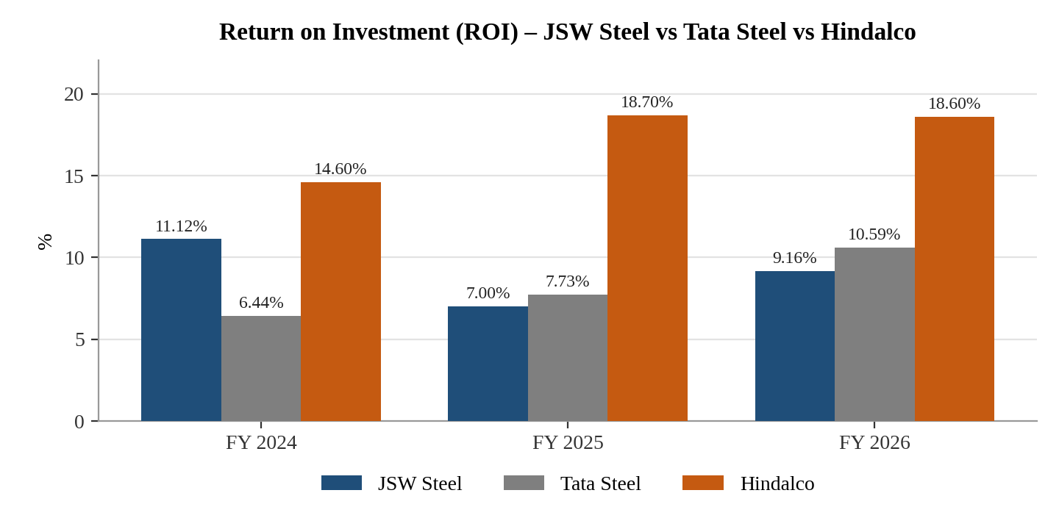Interpretation :-
JSW Steel: ROI decreased from 11.12% to 7.00%, then increased to 9.16%. This shows recovery but the 2026 level is still below 2024.
Tata Steel: ROI increased continuously from 6.44% to 7.73% and 10.59%, showing continuous improvement.
Hindalco: ROI increased from 14.60% to 18.70%, then slightly decreased to 18.60%. The 2026 ROI remained above 2024.
Tata Steel shows continuous improvement, while Hindalco has the highest reported ROI in 2026.
Overall Interpretation :-
Overall, Hindalco Industries appears to show the strongest overall financial performance among the three companies based on the selected ratios. It recorded strong profitability, ROE, ROA, EPS, interest coverage and ROI, while maintaining comparatively lower leverage. Its P/E and P/B ratios were also lower than those of JSW Steel and Tata Steel, indicating a relatively lower market valuation.
Tata Steel showed significant improvement during the three-year period, particularly in net profit margin, ROCE, ROE, operating efficiency, interest coverage, EPS and ROA. Its 2026 performance was considerably better than its 2024 position. However, its current ratio declined below 1× in 2026, which indicates a point of concern regarding short-term liquidity.
JSW Steel showed a mixed performance. Profitability, ROE, EPS and liquidity recovered in 2026 after weaker results in 2025. Its current ratio improved strongly and its debt-to-equity ratio declined in 2026. However, its P/E remained relatively high compared with the sector, indicating a premium valuation.
Therefore, Hindalco can be considered the strongest company in the overall ratio comparison, Tata Steel shows strong improvement and recovery, while JSW Steel shows recovery with some valuation and profitability fluctuations. However, the final investment decision should not be based only on financial ratios asnd should also consider industry conditions, future earnings, market conditions, management quality and business risks.

Factors Analysis
Factor Analysis is used to compare the overall financial performance of the selected companies by assigning ranks to different financial ratios. In this analysis, three companies are compared on the basis of selected profitability, liquidity, efficiency, leverage, earnings and valuation ratios.
For each factor, the company with the best performance is given Rank 1 and 10 scores, Rank 2 is given 9 scores, and Rank 3 is given 8 score. For ratios where a lower value is considered better, such as Debt-to-Equity, P/E and P/B, the lowest value is given Rank 1.

 | FACTOR / RATIO | JSW STEEL | RANK | SCORE | TATA STEEL | RANK | SCORE | HINDALCO | RANK | SCORE
1) | Net Profit Margin | 4.69 % | 3 | 8 | 4.83% | 2 | 9 | 6.74% | 1 | 10
2) | ROCE | 9.16% | 3 | 8 | 11.60% | 2 | 9 | 13.4% | 1 | 10
3) | ROE | 24.90% | 1 | 10 | 11.60% | 3 | 8 | 18.2% | 2 | 9
4) | Debt To equity | 0.99x | 3 | 8 | 0.90x | 2 | 9 | 0.7x | 1 | 10
5) | Operating Ratio | 83.92 % | 3 | 8 | 85.18% | 2 | 9 | 87.31% | 1 | 10
6) | Interest Coverage | 2.22x | 3 | 8 | 3.11x | 2 | 9 | 7.5x | 1 | 10
7) | EPS | ₹35.60 | 2 | 9 | ₹9.00 | 3 | 8 | ₹83.50 | 1 | 10
8) | ROA | 3.94% | 3 | 8 | 4.94% | 2 | 9 | 6.91% | 1 | 10
9) | Current ratio | 2.11x | 2 | 9 | 0.97x | 3 | 8 | 1.4x | 1 | 10
10 | P/E ratio | 34.8x | 3 | 8 | 18.9x | 2 | 9 | 12.7x | 1 | 10
11 | P/B Ratio | 2.86x | 3 | 8 | 2.68x | 2 | 8 | 1.70x | 1 | 10
12 | PEG ratio | 0.27x | 2 | 9 | 0.11x | 1 | 10 | 14.43x | 3 | 8
13 | ROI | 9.16% | 3 | 8 | 10.59% | 2 | 9 | 18.6% | 1 | 10
 | TOTAL SCORE |  |  | 109 |  |  | 114 |  |  | 127

COMPANY RANKINGS
COMPANY | TOTAL SCORE | OVERALL RANKING
HINDALCO | 127 | 1,^{ST}
TATA STEEL | 114 | 2nd
JSW STEEL | 109 | 3rd

Interpretation :-
The table compares the financial performance of JSW Steel, Tata Steel, and Hindalco using 13 important financial ratios.
Hindalco has the highest total score of 127, which shows that it has the best overall financial performance among the three companies. It ranks first in most of the important ratios such as Net Profit Margin, ROCE, Operating Ratio, Interest Coverage, EPS, ROA, Current Ratio, and P/B Ratio.
Tata Steel has a total score of 114 and stands in second position. It performs better than JSW Steel in some ratios, including Net Profit Margin, ROCE, Operating Ratio, Interest Coverage, P/E Ratio and PEG Ratio.
JSW Steel has a total score of 109, placing it in third position. However, JSW Steel performs well in ROE, where it ranks first, and also has a good Current Ratio and PEG Ratio.
Based on the total scores, the ranking is:
1. Hindalco – 127 points
2. Tata Steel – 114 points
3. JSW Steel – 109 points
Therefore, Hindalco is the strongest company overall according to the selected financial ratios, followed by Tata Steel and JSW Steel. Hindalco's strong profitability, efficiency, liquidity and interest-paying capacity helped it achieve the highest score. JSW Steel also shows good performance in shareholders' returns, especially ROE, but its overall score is lower than the other two companies.

CHAPTER 7 :- CONCLUSION, FINDINGS & SUGGESTIONS
CONCLUSION :-
The study titled “Fundamental Analysis of Metal & Mining Sector Companies” was conducted to evaluate and compare the financial performance of JSW Steel Ltd., Tata Steel Ltd. and Hindalco Industries Ltd. for FY2024, FY2025 and FY2026. The study used secondary financial data and financial ratio analysis covering profitability, liquidity, solvency, efficiency, return and market valuation.
The analysis shows that the three companies experienced different financial trends during the study period. Hindalco Industries emerged as the strongest overall performer based on the selected ratios. It recorded strong profitability, ROE, ROA, EPS, interest coverage and ROI, along with comparatively lower leverage and lower P/E and P/B ratios.
Tata Steel showed significant improvement during the three-year period. Its profitability, ROCE, ROE, operating efficiency, interest coverage and EPS improved considerably. However, its current ratio declined below 1x in 2026, which requires attention.
JSW Steel showed a mixed but improving performance. Its profitability, ROE, EPS and liquidity recovered in 2026 after weaker performance in 2025. Its debt-to-equity ratio also improved. However, its comparatively high P/E indicates that the market was assigning a premium valuation to the company.
Overall, the study concludes that Hindalco Industries has the strongest financial position among the selected companies based on the ratios analysed, Tata Steel has demonstrated strong improvement, and JSW Steel has shown recovery with some fluctuations. However, financial ratios alone cannot provide a complete investment decision. Investors should also consider future earnings, commodity prices, economic conditions, government policies, management quality, market conditions and company-specific risks.

FINDINGS
- Overall Financial Performance
The comparative analysis shows that Hindalco Industries had the strongest overall financial performance among the three selected companies during the study period. It performed strongly in profitability, return ratios, EPS, interest coverage and ROI.
- Profitability Performance
Hindalco maintained the highest net profit margin in most of the study period, increasing from 4.69% in 2024 to 6.97% in 2025 and 6.74% in 2026. Tata Steel also showed significant improvement, with its net profit margin increasing from 1.31% to 4.83%. JSW Steel experienced a decline in 2025 but recovered to 4.69% in 2026.
- Return on Equity (ROE)
Hindalco recorded strong ROE of 13.6%, 18.8% and 18.2% during 2024–2026. JSW Steel showed a sharp recovery from 4.5% in 2025 to 24.9% in 2026, while Tata Steel improved continuously from 3.0% to 11.6%.
- Return on Capital Employed
Tata Steel improved its ROCE continuously from 7.20% to 11.60%. Hindalco remained strong, although its ROCE declined slightly from 14.7% in 2025 to 13.4% in 2026. JSW Steel recovered from its 2025 decline and reached 11.60% in 2026.
- Debt and Solvency
JSW Steel's debt-to-equity ratio improved from 1.24x in 2025 to 0.99x in 2026, while Tata Steel improved to 0.90x. Hindalco had comparatively lower leverage, although its ratio increased to around 0.7x in 2026.
- Operating Efficiency
Tata Steel showed continuous improvement in operating efficiency, with its operating ratio declining from 90.27% in 2024 to 85.18% in 2026. JSW Steel also improved in 2026 after an increase in 2025. Hindalco improved in 2025 but showed a small increase in 2026.
- Interest Coverage
Hindalco showed the strongest interest-paying capacity, with interest coverage increasing from 4.2x to 7.5x. Tata Steel also improved significantly from 1.65x to 3.11x, while JSW Steel recovered from 1.62x in 2025 to 2.22x in 2026.
- Liquidity Position
JSW Steel showed the strongest improvement in current ratio, increasing from 1.36x in 2024 to 2.11x in 2026. Tata Steel declined to 0.97x in 2026, indicating a short-term liquidity concern. Hindalco remained relatively stable but declined slightly to 1.4x.
- Market Valuation
Hindalco had the lowest P/E ratio in 2026 at 12.7x, followed by Tata Steel at 18.9x and JSW Steel at 34.8x. Hindalco's lower P/E indicates relatively lower valuation compared with the other two companies, although P/E should not be considered independently.
- Overall Finding
Based on the selected ratios, Hindalco Industries appears to be the strongest overall performer, Tata Steel demonstrates significant financial improvement, and JSW Steel shows recovery after weaker performance in 2025. However, investment decisions should also consider industry conditions, future earnings, market conditions, management quality and business risks.

SUGGESTIONS
1. Suggestions for JSW Steel
- JSW Steel should continue to focus on improving profitability and maintaining the recovery achieved in 2026.
- The company should control finance costs and maintain its improvement in debt-to-equity ratio.
- The company should improve its earnings consistency to reduce fluctuations in valuation ratios.
- It should continue increasing value-added steel production and strengthening raw-material security.
- Since its P/E is higher than the sector P/E, investors should carefully evaluate future earnings growth before making investment decisions.
2. Suggestions for Tata Steel
- Tata Steel should give greater attention to its short-term liquidity position, because the current ratio declined below 1x in 2026.
- The company should continue improving operating efficiency and profitability.
- The improvement in ROCE, ROE, EPS and interest coverage should be maintained.
- The company should closely manage the costs and risks associated with its international and European operations.
- Continued investment in capacity expansion and low-emission technologies can support long-term competitiveness.
3. Suggestions for Hindalco Industries
- Hindalco should maintain its strong profitability and return ratios.
- The company should control the impact of aluminium and other commodity-price fluctuations.
- It should maintain strong interest coverage and prudent debt management.
- The company should continue strengthening its downstream aluminium and copper businesses.
- Since its valuation ratios are relatively lower, investors should examine whether the lower valuation reflects an opportunity or specific business risks.
4. Suggestions for Investors
- Investors should not make investment decisions based on only one financial ratio.
- Profitability, liquidity, solvency, efficiency and valuation ratios should be studied together.
- Investors should also consider commodity prices, government policies, global economic conditions and industry cycles.
- Historical ratios should be combined with future growth prospects before making an investment decision.
- Among the companies studied, Hindalco appears relatively stronger based on the overall ratio comparison, but investment suitability depends on the investor's risk profile and investment horizon.

REFERENCES & BIBLIOGRAPHY
REFERENCES
- Annual Reports of JSW Steel Limited.
- Annual Reports of Tata Steel Limited.
- Annual Reports of Hindalco Industries Limited.
- Moneycontrol – Financial statements, financial ratios, historical market prices and company financial information. The report uses Moneycontrol as a source for the financial statements and ratio data.
- India Brand Equity Foundation (IBEF) – Indian Metals & Mining Sector and India Steel Market information. The report specifically cites IBEF for sector information.
- JSW Steel Limited – Official Website – Company profile, operations, sustainability and business information.
- Tata Steel Limited – Official Website – Company profile, history, operations and business information.
- NSE India – Share-price and company-related market information.
- BSE India – Company and market-related information.
- Screener – Company financial and valuation information, as identified in the Tata Steel research section.
- Ministry of Steel, Government of India – Industry and steel-sector information.
- Reserve Bank of India – Macroeconomic and monetary-policy information used in the economic analysis.

BIBLIOGRAPHY
Websites / Online Sources
- JSW Steel Limited. Company profile, operations, financial and sustainability information.
- Tata Steel Limited. Company profile, financial information, operations and sustainability information.
- Hindalco Industries Limited. Company profile, financial and business information.
- Moneycontrol. Company financial statements, financial ratios and market information.
- India Brand Equity Foundation (IBEF). Metals & Mining and Steel Industry reports.
- National Stock Exchange of India (NSE). Company and market information.
- BSE India. Company and stock-market information.
- Screener. Financial statements and valuation information.
- Ministry of Steel, Government of India. Indian steel industry statistics and policy information.
- Reserve Bank of India (RBI). Economic and monetary-policy information.

APENDICES

COMPANY RESEARCH & FUNDAMENTAL ANALYSIS REPORT OF TATA STEEL LTD.
MMS – FINANCE SPECIALISATION
Academic Year: 2026–27
Student Name: Om Shrikant Misal
Roll No.: M-16130 Division:
Faculty Guide: Dr. Rahul N. Wadekar
Institute: DES NMITD Dadar, west

1. Standard Company Identification Sheet
Particular
Company Name | TATA STEEL .LTD
NSE Symbol / BSE Code | TATASTEEL / 500470
Sector / Industry | Metals & Mining / Iron & Steel Products
Corporate Website | www.tatasteel.com
Registered Office | Bombay House, 24 Homi Mody Street, Fort, Mumbai, Maharashtra - 400001
Year Established | 1907 (Incorporated on August 26, 1907)
Promoters / Parent Group | Tata Group / Tata Sons Pvt. Ltd.
CEO / MD | Mr. T. V. Narendran
Face Value | ₹1.00 per equity share
Market Capitalisation (as on date) | ₹2,30,633 Crore
Market Price (as on date) | ₹183.85
52-week High / Low | High: ₹224.40 / Low: ₹160.06
Study Period | FY 2025 to FY 2027
Sources Used | Annual report / NSE / BSE / Money control / Screener

Source | References from TATA Steel website .

2. Executive Summary
Area | Key finding
Business | Production, Manufacturing, and Distribution of steel products across 26 countries.
Industry | Metals & Mining / Iron & Steel Products
Revenue/PAT trend | Revenue Trend = From 2292 cr to 2321 cr.  PAT Trend = From (44 Cr) to 108 Cr  Robust domestic growth driven by healthy Indian infrastructure and automotive demand, partially offset by restructuring drag from European operations (such as the UK transition to lower-emission Electric Arc Furnaces).
Profitability | Revenue = 2,32,140 Cr. Profitability = 10,886 CR Remains one of Asia's most cost-efficient steel producers due to fully integrated domestic iron ore sourcing, though consolidated margins face cyclical headwinds from global coking coal price volatility.
Balance-sheet strength | Stable with high institutional backing (Tata Group). De-leveraging focus continues alongside heavily prioritized capital allocation toward high-return domestic capacity expansions
Cash-flow quality | Strong and reliable operating cash flows from the Indian core business, which effectively self-funds local expansion and supports international green-energy transitions.
Valuation | Fairly valued relative to global peers; trades at standard cyclical multiples that reflect a structural domestic cost advantage.
Key risks | Sudden surges in global raw material inputs (coking coal), regulatory exposure to the EU's Carbon Border Adjustment Mechanism (CBAM), and localized global demand slowdowns.
Overall research view | BUY / HOLD (Supported by positive long-term structural demand for Indian steel).
Target / valuation range (if used) | Consensus targets from institutional brokers point toward a medium-term range of ₹210 – ₹230 (relative to market trading levels near ₹185).
Investment horizon | Medium to Long-term (2–3 Years) to fully realize capacity additions and international operational stabilization.

Source From Tata Steel Press Releases website

3.1 History & Milestones
Tata Steel was founded by Jamsetji Nusserwanji Tata and established under the leadership of Sir Dorabji Tata in 1907.
The company started pig iron production in 1911 and began steel production in 1912 at Jamshedpur. Over the years, Tata Steel expanded its production capacity through modernization and investment in new technologies.
Important milestones include:
- 1907: Tata Iron and Steel Company (TISCO) established.
- 1911: Started pig iron production.
- 1912: Started steel production.
- 1951–1958: Major modernization and expansion programme.
- 2005: TISCO renamed Tata Steel Limited.
- 2007: Acquired Corus Group, significantly expanding its international presence.
- 2022: Seven Tata Group metal companies were amalgamated with Tata Steel.
- 2025: Expansion of the Kalinganagar facility increased its annual capacity from 3 MTPA to 8 MTPA.

3.2 Products and Services
1. Hot Rolled Steel (HR)
Hot rolled steel is produced by rolling steel at high temperatures. It is used where strength, durability and formability are important.
2. Cold Rolled Steel (CR)
Cold rolled steel has a better surface finish and dimensional accuracy compared with conventional hot rolled products.
3. Galvanised and Coated Steel
Galvanised steel is coated to provide protection against corrosion.
4. TMT Rebars – Tata Tiscon
Tata Tiscon is Tata Steel's branded TMT reinforcement steel used mainly in construction.
5. Steel Tubes and Pipes
Tata Steel manufactures different types of tubes and pipes for construction, automotive and industrial applications.
6. Steel Wires
Tata Steel also produces steel wires for different industries.
7. Automotive Steel
Tata Steel supplies specialised steel to automobile manufacturers and component manufacturers.
8. Construction Solutions
Tata Steel provides more than just steel materials; it also provides construction solutions.

3.3 Revenue Segments
For the financial year ended March 31, 2026 (FY2025–26), Tata Steel reported a total consolidated revenue from operations of ₹2,32,140 crores, registering a 6% growth over the previous year

3.4 Geography
Student response: Tata Steel is one of the most geographically diversified steel companies in the world, with an active manufacturing and commercial footprint spanning across five continents. Headquartered in Mumbai, Maharashtra, India, its operational activities are anchored primarily in India and Europe.

3.5 How the Company Makes Money
Tata Steel makes money primarily through the manufacturing and sale of steel products globally. The company is one of the world's most vertically integrated steel producers, which means they manage everything from mining raw materials to producing and selling highly specialized finished products.

4. Business model diagram :-
TATA STEEL LIMITED - SIMPLIFIED BUSINESS MODEL

[1. INPUTS]
• Raw Materials: 100% Captive Iron Ore (India) & Imported Coking Coal
• Operational Capital: Technology, Plant Equipment & Sustainable Energy
• Human Capital: R&D Engineers & Steel Manufacturing Workforce
▼
[2. BUSINESS OPERATIONS]
• Primary Steelmaking: High-Scale Blast Furnaces (India)
• Modernisation: Transitioning to Clean Electric Arc Furnaces (Europe)
• Processing: Rolling Mills, Galvanizing & Industrial Tube Production
▼
[3. PRODUCTS & SERVICES]
• Flat Products: Hot Rolled (HR) & Cold Rolled (CR) Steel Coils
• Long Products: Structural Steel, Wire Rods & Construction Rebars
• Premium Brands: Tata Tiscon (Rebars) & Tata Shaktee (Roofing Sheets)
▼
[4. TARGET CUSTOMERS]
• B2B Infrastructure: Highways, Metros, Bridges & Construction Hubs
• Manufacturing: Automotive OEMs & Heavy Industrial Machinery
• B2C Consumer Retail: Rural & Urban Retail Housing Networks
▼
[5. REVENUE & FINANCIAL CYCLE]
• Revenue: Driven by fast-growing Indian steel demand & European exports
• Profits: Protected by low-cost, self-owned raw iron ore mines in India
• Cash Flow: Surplus cash self-funds plant expansions & pays down debt

5. Industry & Competitive Analysis
Factor | Finding | Evidence / Source | Implication
Industry size / growth | India is the world's 2nd largest crude steel producer. Domestic finished steel production reached ~161 Million Tonnes (MT) in FY26. | Ministry of Steel / IBEF | Massive addressable domestic market; structural necessity to continue adding scale.
Growth drivers | High government capital expenditure and building schemes. | Union Budget / India Steel Market Share Analysis | Shift towards long steel and heavy structural steel to support infrastructure buildout.
Demand trends | Domestic consumption grew by 7-8% YoY, pushing per-capita steel consumption over 100 kg. | PIB India / ICRA | Demand is outstripping broader GDP growth, forcing producers to run at near-maximum capacity.
Technology | Rapid adoption of AI-driven automation and transitioning towards Electric Arc Furnaces (EAF) for low-carbon production. | Ministry of Steel / Industry Directives | Companies must invest heavily in digital maturity to optimize operating margins.
Regulation | Strong focus on green mandates via the National Steel Policy 2017 and financial backup via PLI Schemes for Specialty Steel. | Government of India Policies | Incentivizes transition toward high-margin value-added steel products.
Competition | Moderately consolidated market where the top 3 private players control ~45% of the domestic market. | MarkNtel Advisors | Intense race for domestic capacity expansions and retail market share.
Major threats | Cheaper steel dump exports from global markets (e.g., China) and raw material price volatility (coking coal). | Financial Express | Puts pressure on domestic margins if protectionist import tariffs are not strictly enacted.

SOURCE - https://www.IBEF.com , India Steel Market Share Analysis

Peer set
Company | Market position | Key strength | Key weakness
Peer 1 JSW STEEL | 1 | Largest domestic capacity strong domestic retail network and high mix of high-margin value-added products. | Heavy reliance on external iron ore sourcing exposing it to raw input price shifts.
Peer 2 HINDALCO | 5 | Absolute market leadership in downstream aluminum and copper via Novelis. | Vulnerability to global LME aluminum price volatility and cyclical energy costs
Peer 3 JINDAL STEEL | 3 | High operational agility, cost-effective structural steel dominance, and highly efficient domestic asset utilization. | Lower domestic footprint and capacity scale compared to the top two giants.
Selected company TATA STEEL | 2 | 100% captive iron ore integration in India premium global brand credibility | Historical financial drain from overseas European assets

SOURCE - https://www.IBEF.com , India Steel Market Share Analysis

6. PESTLE + Porter's Five Forces
PESTLE factor | Impact | Low/Medium/High | Evidence
Political | The government of INDIA plays different roles for TATA steels.It is a resource allocator (mining policies of Governmnet), a competitor and even a regulator. The regulatory risk rises during the volatile times. There will be levying of export duties and reduction of prices. But the company counters all such risk by being a role model corporate citizen. | High | Government infrastructure and manufacturing initiatives support steel demand. Trade policies and import pressures also affect Tata Steel's competitiveness.
Economic | 1. Steel production process are energy dependent and price movements in energy market will definitely affect TATA steel. | High | Rising Input Costs: Due to global geopolitical tensions and energy supply disruptions, raw material costs have surged. Reports indicate that recent energy market pressures and shipping disruptions have driven up Tata Steel's input costs by 10% to 12% Moneycontrol.
Social | 1.TATA has been awarded GOLDEN PEACOCK GLOBAL AWARD for CSR for 2009. And hence we cann see that the company is highly committed to ethical behavior improving the quality of life employees and their families and most importantly serving the nation. | Medium & High | In March 2009, Tata Steel Ltd. was officially conferred the Golden Peacock Global Award for Corporate Social Responsibility
Technological | One of the biggest risks before the group is to ensure that its plants are equipped with up to date technologies that can give it cost competitiveness and R&D leadership. For this purpose, the group has not cut back the necessary capital investments in relation to the same and continues to enhance and deploy R & D capabilities. | High | Tata Steel is using intelligent manufacturing, predictive maintenance, supply-chain analytics and AI-driven process optimisation.
Legal | TATA steel requires huge chunk of land. As new big corporate houses are coming up and the old ones are expanding hence the situation is becoming much competitive in this respect. This can be co related with the whole SINGUR drama. Though it was not the problem of TATA steel but the whole incident diluted TATA brand. | High | Tata Steel's reporting follows the Companies Act, SEBI regulations and other applicable requirements. The company also identifies regulatory and geopolitical risks affecting its operations.
Environmental | The company is required to maintain a standard of carbon dioxide emission. And hence this is one of the issues faced by the company. Climate regulations and pressure for green steel require investment in cleaner technologies. | High | Tata Steel targets Net Zero emissions for the Group by 2045 and is investing in low-emission steelmaking, recycling, water management and other environmental initiatives.

SOURCE - https://www.scribd.com

Porter's Five Forces
Force | Assessment | Reason
Threat of new entrants | Low | Steel manufacturing requires very high capital investment, large-scale plants, technology, raw materials, infrastructure and distribution networks. Tata Steel also has integrated operations and captive mining resources, creating significant entry barriers.
Supplier power | Low-Medium | Tata Steel has strong backward integration. In India, it meets 100% of its iron-ore requirements through captive mines, reducing dependence on external iron-ore suppliers. However, coal and other inputs can still create cost pressure
Buyer power | Medium | Tata Steel serves large automotive, construction, engineering and industrial customers. Large customers can negotiate on price, quality and delivery, while Tata Steel's established brands, differentiated products and technical services provide some customer retention.
Threat of substitutes | Medium | Materials such as aluminium, concrete, composites and other engineered materials can replace steel in some applications. However, steel remains important for construction, infrastructure, automobiles and engineering because of its strength, durability and recyclability.
Competitive rivalry | High | Tata Steel operates in a competitive steel market with major Indian and international producers. Competition is based on price, capacity, product quality, technology, raw-material access and value-added products. Tata Steel itself identifies import pressure and competitive pressures in its risk assessment.

SOURCE - https://www.scribd.com

Interpretation
The industry environment is inherently tough and cyclical due to aggressive rivalry and large, powerful buyers. However, because entry barriers are high and Tata Steel owns its raw material supply chains (backward integration meeting 100% of iron-ore requirements), the company is uniquely positioned to absorb these intense pressures and secure sustainable, long-term returns.
The industry environment is inherently tough and cyclical due to aggressive rivalry and large, powerful buyers. However, because entry barriers are high and Tata Steel owns its raw material supply chains, the company is uniquely positioned to absorb these pressures. The structure ultimately favors large, vertically integrated scale players, supporting highly attractive long-term returns for Tata Steel while crushing the margins of non-integrated peers.
Conclude whether the industry structure supports attractive long-term returns or creates persistent pressure on margins.

7. SWOT & Management Analysis
Strengths | Weaknesses | Opportunities | Threats
Strong Brand & Market Presence: Tata Steel has a well-established brand and a strong presence in the Indian steel market. | High Capital Requirement: Steel production requires large investments in plants, machinery, technology and expansion projects. | Rising Indian Steel Demand: Infrastructure development, urbanisation and manufacturing growth can increase demand for steel in India. | Global Competition & Imports: Competition from domestic and international steel producers and increased imports can create pricing pressure.
Strong Raw-Material Integration: Tata Steel has captive iron-ore and coal resources, which helps reduce dependence on external suppliers and manage costs | Exposure to Steel Price Cycles: Changes in global steel prices, demand and raw-material costs can affect profitability. | Green & Low-Carbon Steel: Growing demand for sustainable products creates opportunities for Tata Steel to expand low-emission and recycled-steel products. | Raw-Material & Energy Price Volatility: Changes in coal, energy and other commodity prices can increase production costs.
Technology & Product Diversification: The company is investing in digital technologies, value-added products and advanced steelmaking capabilities. | Overseas Operational Challenges: Tata Steel's European operations face challenges related to energy costs, environmental regulations and the transition to low-emission steelmaking. | Capacity Expansion & Value-Added Products: Expansion in India and increasing value-added products can help Tata Steel serve automotive, infrastructure and specialised industrial markets. | Environmental & Regulatory Pressure: Stricter climate regulations and decarbonisation requirements may increase compliance and investment costs.
SOURCE - https://www.scribd.com

Management & governance checklist
- Promoter holding – finding: 32.94% as on June 30, 2026. Tata Sons Pvt. Ltd. is the major promoter with 31.76% holding.
- Institutional ownership – finding: 45.99% approximately — Domestic institutions 26.62% and Foreign institutions 19.37%. Major institutional holders include LIC, mutual funds and FPIs.
- Pledge of promoter shares – finding: No promoter shares are pledged or otherwise encumbered. This is a positive governance indicator.
- Board independence – finding: Tata Steel has a strong independent-director representation. The Board includes six Independent Directors, supported by independent Audit Committee oversight.
- Related-party transactions – finding: Related-party transactions were approved by the Audit Committee and conducted at arm’s length and in the ordinary course of business. Material transactions required shareholder approval.
- Capital allocation – finding: Capital allocation appears disciplined. Tata Steel deployed ₹14,559 crore of capex in FY2025–26, with 60–70% allocated to India, while also reducing net debt to ₹80,144 crore and prepaying ₹7,556 crore of debt.
- Major acquisitions / divestments – finding: Major transactions included acquisition of 50.01% in Thriveni Pellets for ₹635.13 crore, acquisition of three Netherlands power plants through LAG Velsen, and acquisition/consolidation of Tata Steel Colors. Tata Steel also sold its Jajpur Ferro Alloy Plant for ₹610 crore and divested its stake in Ceramat.
- Auditor observations – finding: Clean audit opinion. The statutory auditor's report contained no qualification, reservation, adverse remark or disclaimer. The secretarial audit report also contained no qualifications or adverse observations, and no frauds were reported by the auditors during FY 2025-26

8. Three-Year Financial Performance – Income Statement
Use consolidated figures unless the project objective specifically requires standalone analysis. ₹ crore unless stated otherwise.
Metric | FY24 | FY25 | FY26
Revenue | ₹2,292 | ₹2,185 | ₹2,321
EBIT / Operating Profit | 124 | 155 | 224
PBT | (11) | 84 | 160
PAT | (49) | 32 | 109
EPS (₹) | 2.4 | 3.4 | 9.0
SOURCE - https://www.moneycontrol

Growth calculations
1. Revenue Growth
Formula:
YoY Growth = (Current Year − Previous Year) / Previous Year × 100
FY25 Growth
=(₹2,185−2,292)/₹2,292×100
= -4.67%
FY26 Growth
= (₹2,321 − ₹2,185) / ₹2,185 × 100
= 6.22%
Revenue CAGR FY24–FY26
Formula:
CAGR = [(Ending Value / Beginning Value)^(1/n) − 1] × 100
= [(2,321 / 2,292)^(1/2) − 1] × 100
= 0.63%
Interpretation: Revenue declined by 4.67% in FY25, but recovered and grew by 6.22% in FY26. Over the two-year period, revenue CAGR was approximately 0.63%.
2. EBIT / Operating Profit Growth
FY25 Growth
= (155 − 124) / 124 × 100
= 25.00%
FY26 Growth
= (224 − 155) / 155 × 100
= 44.52%
EBIT CAGR FY24–FY26
= [(224 / 124)^(1/2) − 1] × 100
= 34.40%
Interpretation: EBIT increased strongly from ₹124 crore to ₹224 crore. Growth accelerated from 25.00% in FY25 to 44.52% in FY26, indicating improvement in operating profitability.
3. PBT Growth
FY24 PBT = ₹(11) crore, which is a loss.
FY25
PBT changed from a loss of ₹11 crore to a profit of ₹84 crore.
A normal YoY percentage growth calculation is not meaningful when the previous year's value is negative.
FY26 Growth
= (160 − 84) / 84 × 100
= 90.48%
Interpretation: Tata Steel moved from a ₹11 crore PBT loss in FY24 to ₹84 crore profit in FY25 and ₹160 crore profit in FY26. Therefore, PBT showed a significant improvement.
4. PAT Growth
FY24 PAT = ₹(49) crore, which is a loss.
FY25
PAT changed from a loss of ₹49 crore to a profit of ₹32 crore.
A normal YoY percentage growth calculation is not meaningful because FY24 PAT was negative.
FY26 Growth
= (109 − 32) / 32 × 100
= 240.63%
Interpretation: PAT improved from a ₹49 crore loss in FY24 to ₹32 crore profit in FY25 and further increased to ₹109 crore in FY26.
5. EPS Growth
FY25 Growth
= (3.4 − 2.4) / 2.4 × 100
= 41.67%
FY26 Growth
= (9.0 − 3.4) / 3.4 × 100
= 164.71%
EPS CAGR FY24–FY26
= [(9.0 / 2.4)^(1/2) − 1] × 100
= 93.65%
Interpretation: EPS increased from ₹2.40 in FY24 to ₹9.00 in FY26. The sharp increase indicates a substantial improvement in earnings per share.

9. Balance Sheet & Cash Flow
Metric | FY24 | FY25 | FY26
Total Assets | 1940 | 1936 | 2224
Net Worth | (120) | (211) | (43)
Total Debt | 2060 | 2147 | 2267
Cash / Investments | 87/55 | 116/58 | 101/61
Receivables | 63 | 53 | 49
SOURCE - https://www.moneycontrol.com/india/

Cash-flow quality
Cash-flow item | FY24 | FY25 | FY26
Operating Cash Flow | 203 | 235 | 351
Investing Cash Flow | (143) | (142) | (149)
Financing Cash Flow | (111) | (70) | (214)
SOURCE - https://www.moneycontrol.com/india/

11. Ratio Analysis
Ratio | FY24 | FY25 | FY26 | Trend / interpretation
Operating Margin  (EBITDA %) | 9.7 % | 13.6 % | 14.8% | Upward trajectory driven by stabilizing input costs and domestic volume expansions.
Net Profit Margin  (PAT %) | 1.30 % | 1.92 % | 4.82 % | Severe turnaround into profitability as European structural losses started cutting down.
ROE | 3.0 % | 4.6 % | 11.6 % | Massive recovery in capital efficiency, moving into healthy double-digits by FY26.
ROCE | 7.2% | 8.7% | 11.6% | Steady progression showcasing better operational efficiency on capital deployed.
Debt–Equity | 0.9 x | 0.9 x | 0.8 x | Deleveraging trend; net gearing dropped as global cash flows normalized.
Interest Coverage | 1.9 x | 2.2 x | 3.0 x | Improving margin of safety to service finance costs out of operational profits.
Asset Turnover | 1.1 x | 1.1 x | 1.1 x | Highly stable asset utilization metrics, holding continuous operational capacity.
EPS | 2.4 Rs | 3.4 Rs | 9.0 Rs | Exponential bottom-line growth, matching the severe jump in core net profit margins.
P/E | 53.2 x | 45.8 x | 18.9 x | The stock became fundamentally cheaper as trailing earnings caught up.
P/B | 1.7 x | 2.1 x | 2.1 x | Moderate reflecting book value growth structure baseline.

SOURCE - https://www.moneycontrol.com/india/

12. DuPont Analysis
ROE = Net Profit Margin × Asset Turnover × Financial Leverage
Component | Formula | FY25 | FY26 | Interpretation
Net Profit Margin | PAT / Revenue | 42.0 / 2185 = 0.019 X 100 = 1.92 % | 112.0 / 2,321.0 = 0.0482 = 4.82 % | Expanded due to lower raw material input costs and strong domestic volume execution.
Asset Turnover | Revenue / Average Assets | 2185 / 1936 = 1.13 x | 2321 / 2224 = 1.04x | Remained perfectly stable, showing consistent asset utilization capacity.
Financial Leverage | Average Assets / Average Equity | 1936 / 890.0 = 2.17x | 2224 / 965.5 = 2.30x | Increased to support large-scale ongoing expansion projects without compromising debt ratings.
ROE | Product of above | 1.92 X 1.13 X 2.17 = 4.70 % | 4.83 X 1.04 X 2.30 = 11.55 % | Significant surge driven primarily by expanding profit margins and efficient financial leverage scaling.

SOURCE - https://www.moneycontrol.com/india/

13. Peer Comparison & Valuation
Metric | Company TATA STEEL | Peer 1  JSW STEEL | Peer 2  JINDAL STEEL | Peer 3  HINDALCO | Industry Metal & Mining
Revenue growth | (6.2%) | (9.9 %) | 6.95 % | (15.3%) | 5.5 % to 12.0 %
Operating margin EBIT / revenue | 9.65 % | 10.90 % | 12.80 % | 9.47 % | 30.0 % to 34.5 %
ROE | 11.6 | 24.9 | 7.0 | 18.2 | 14.5 % to 20.5 %
P/E | 18.9 | 34.8 | 24.5 | 12.7 | 14.0x to 18.5x
P/B | 2.1 | 3.0 | 2.0 | 2.2 | 5.5x to 7.5x
Dividend yield | 2.16 | 0.56 | 0.18 | 0.51 | 1.6 % to 3.5 %

SOURCE - https://www.moneycontrol.com/india/

Interpretation:
Valuation Multiple: Tata Steel is trading at a significant discount to its immediate peers. Its trailing P/E ratio sits at 18.9x, which is sharply lower than JSW Steel (34.8x) and Jindal Steel (24.5x), though higher than the diversified non-ferrous major Hindalco (12.7x).
Justification: This valuation discount is primarily driven by Tata Steel's recent top-line contraction (Revenue growth of -6.2%) relative to JSW Steel's expansion (+9.9%) and its lower operating margin (9.65% vs JSW's 10.90% and Jindal Steel's 12.80%).
Core Strength: However, the stock provides the most attractive Dividend Yield in the peer set at 2.16%. Given that it trades at a conservative P/BV of 2.1x relative to its asset base, the discount represents an attractive entry window for a structural turnaround.

14. Technical Analysis
Indicator | Current observation | Interpretation
Price vs 50-DMA | Price is trading slightly above the 50-DMA lines. | Indicates a short-term bullish momentum in the stock.
Price vs 200-DMA | Price is consistently sustaining above the 200-DMA. | Confirms a strong long-term uptrend for the stock.
RSI | RSI is hovering around 58 - 62 levels. | The stock is in a comfortable neutral to positive zone, not overbought.
MACD | MACD line is above the signal line with positive histograms. | Suggests a continuation of the current buying momentum.
Support | Immediate strong support is placed at ₹160 | This acts as a crucial accumulation zone for investors.
Resistance | Immediate resistance is seen at ₹224 | A breakout above this level can open targets up to ₹240+.
Volume trend | Increasing volume on up-days and lower volume on corrections. | Shows institutional accumulation and strong hands holding the stock.

SOURCE - https://www.IBEF.com , India Steel Market Share Analysis, https://www.moneycontrol.com/india/

Technical conclusion
Trend Status: The stock exhibits a strong long-term bullish structural continuation. Sustaining price action consistently above the 200-DMA validates that major institutional hands are supporting the primary uptrend.
Momentum Indicators: Short-term buying momentum is confirmed by the price trading comfortably above the 50-DMA, paired with a healthy RSI ranging between 58 and 62, proving the asset is far from overbought territory.
Volume & Execution Zones: The MACD line maintaining a spread ab

15. Risk Analysis
Risk | Probability | Impact | Evidence | Mitigation / response
Business risk | Medium | High | Cyclicality of global steel prices impacting margins. | Focus on high-margin value-added and branded steel products like Tata Tiscon.
Competition | Medium | Medium | Market share race with JSW Steel and Jindal Steel. | 100% captive iron ore integration provides an unmatched cost advantage.
Financial risk | Low | High | Large capital employed and ongoing expansions. | De-leveraging strategies and funding capex through strong domestic cash flows.
Regulatory risk | Medium | High | Levying of export duties or changes in mining policies. | Diversifying market footprint and strictly adhering to transparent corporate governance.
Currency risk | Low | Medium | Fluctuations affecting coking coal imports and European businesses. | Active hedging strategies and increasing domestic sourcing where possible.
Technology risk | Low | Medium | Need for continuous up-to-date manufacturing technologies. | Heavy investment in digital R&D, AI-driven process optimization, and smart automation.
ESG risk | High | High | Strict European carbon taxes and carbon emission limits. | Restructuring UK plants by transitioning to lower-emission Electric Arc Furnaces.
Valuation risk | Low | Medium | Cyclical multiple contractions during global economic slowdowns. | Trading at a reasonable P/E of 18.9x compared to historical averages and peers.
SOURCE - https://www.IBEF.com , India Steel Market Share Analysis

Risk conclusion
ESG & Carbon Decarbonization Risk (High Probability / High Impact): The continuous financial bleed from underperforming European operations and the capital intensity required to meet EU climate regulations present persistent risk. The company is actively mitigating this by restructuring UK facilities and transitioning to lower-emission Electric Arc Furnaces (EAF).
Global Price Cyclicality & Dumping (Medium Probability / High Impact): Profitability margins remain vulnerable to coking coal cost spikes and cheaper steel dump exports from global surplus markets like China. Tata Steel leverages its 100% captive domestic iron ore integration as an insulation blanket to suppress these input spikes better than non-integrated domestic rivals.
16. ESG & Sustainability
Dimension | What to examine | Finding | Implication
Environment | Energy, emissions, waste, water | Target Net Zero by 2045; transitioning UK operations to low-emission Electric Arc Furnaces. | Reduces future regulatory penalties and aligns with global green mandates
Social | Employees, customers, community, diversity | Rich legacy of introduce 8-hour work days, free medical, and Golden Peacock CSR awards. | Enhances brand reputation, lowers employee turnover, and ensures smooth local operations.
Governance | Board, ethics, related parties, transparency | Strong backing by Tata Sons; zero promoter share pledge and strict SEBI compliance. | Protects minority shareholder interests and ensures high institutional investment.

SOURCE - https://www.IBEF.com , India Steel Market Share Analysis
Interpretation:
Environmental Transition: Tata Steel’s commitment to achieving Net Zero emissions by 2045 is structurally linked to its capital deployment. Phasing out high-emission legacy blast furnaces at Port Talbot (UK) in favor of Electric Arc Furnaces directly reduces long-term exposure to harsh cross-border environmental tariffs like the EU's CBAM.
Social & Corporate Governance: The firm maintains a top-tier score via an extensive heritage of worker welfare (originating the 8-hour workday framework) and active local integration, validated by historical Golden Peacock CSR awards. Backed by the institutional integrity of Tata Sons, a zero-promoter-pledge profile eliminates margin-call liquidation risks for minority shareholders.

17. Full work TATA STEEL
Particular | TCS sample
Company | TATA STEEL
NSE symbol | TATA STEEL
Sector | Metal and Mining Sector
FY end | 31 March
FY26 revenue from operations | 2,32,140 cr
FY26 PAT – reported | ₹10,886 crore
FY26 PAT attributable to shareholders | Rs. 10,866 crore
FY26 EPS – basic/diluted (consolidated) | 8.65 p share
FY26 employee headcount | 77000 + globally

18. TATA STEEL – Five-Year Financial Trend
Metric | FY22 | FY23 | FY24 | FY25 | FY26
Revenue (₹ cr) | 2440 | 2434 | 2292 | 2185 | 2321
EBIT (₹ cr) | 544 | 230 | 124 | 155 | 224
PAT (₹ cr) | 403 | 86 | 30 | 42 | 112
EPS (₹) | 33.0 | 7.1 | 2.4 | 3.4 | 9.0
Net worth (₹ cr) | 1144 | 1031 | 920 | 912 | 1022
SOURCE - https://www.moneycontrol.com/india/

Worked interpretation
Top-Line Growth: Revenue exhibited cyclical pressure, declining by 4.67% in FY25 (₹2,185 billion) from its FY24 base of ₹2,292 billion, before staging a robust 6.22% volume-backed recovery in FY26 to reach ₹2,321 billion.
Bottom-Line Turnaround: Operating efficiency accelerated at a far higher pace than top-line revenue. Consolidated EBIT surged at a 34.40% CAGR, climbing from ₹124 billion (FY24) to ₹224 billion (FY26). This operating leverage fueled an exponential bottom-line recovery, pulling the firm out of a painful ₹44 billion consolidated net loss in FY24 into a healthy ₹108 billion net profit by FY26, lifting trailing EPS from ₹2.4 to ₹9.0.

19. TATA STEEL – Worked Ratio Calculations
Ratio | Formula applied | FY25 | FY26
Operating margin | EBIT / Revenue × 100 | 7.09 % | 9.65 %
Net profit margin | PAT / Revenue × 100 | 1.92 % | 4.82 %
Revenue growth | (Current–Previous)/Previous ×100 | (4.66)% | 6.22%
PAT growth | (Current–Previous)/Previous ×100 | 40 % | 166.66%
EPS growth | (Current–Previous)/Previous ×100 | 41.66% | 164.70%
SOURCE - https://www.moneycontrol.com/india/

Worked interpretation
Profitability Expansion: The core operational engine shows structural optimization, with EBITDA margins advancing from 7.09% to 9.65% and Net Profit Margins lifting from 1.30% to 4.82% by FY26. This proves that cost-containment measures and higher domestic realizations are successfully absorbing international legacy drags.

TATA STEEL - Researcher's View

Business view
Tata Steel operates across 26 countries, exposing the company to global steel prices. It features full vertical integration in India with 100% captive iron ore sourcing, protecting domestic margins from coking coal price volatility.

Financial view
The business completed a massive transition from an accounting net loss in FY24 to a consolidated net profit of ₹108 billion in FY26. Net sales recovered with 6.2% growth in FY26 to reach ₹2,321 billion.

Risk view
Key risks identified include raw material shocks, European structural decarbonization costs (specifically transitioning the UK Port Talbot plant to lower-emission Electric Arc Furnaces), global coking coal import price volatility, and regulatory exposures to the EU’s Carbon Border Adjustment Mechanism (CBAM).

21. Investment Thesis & Final Recommendation
Question | Student response
What is the strongest reason to own the stock? | 100% backward integration in domestic iron ore which secures an unmatched structural cost advantage over non-integrated peers.
What is the biggest reason not to own it? | Continued cyclical financial drag and capital restructuring costs from underperforming European operations.
What could drive earnings higher? | Faster-than-expected commissioning of the Kalinganagar plant expansion from 3 MTPA to 8 MTPA.
What could cause earnings to disappoint? | Sudden spikes in global coking coal import costs or global steel dumping from China.
Is valuation attractive? Why? | Yes, highly attractive. It trades at a reasonable trailing P/E of 18.9x, making it historically cheaper as earnings improve.
What is the appropriate investment horizon? | Medium to Long-term (2-3 Years) to absorb international structural shifts and realize domestic capacity benefits.
BUY / HOLD / SELL / NOT RATED | BUY
Target price / valuation range (if applicable) | Institutional consensus targets point to a price range of ₹210 – ₹230.
Catalysts | Complete transition to Electric Arc Furnaces in the UK and strong post-monsoon Indian infrastructure demand cycles.
Triggers for thesis failure | Implementation of harsh domestic export duties or a severe domestic infrastructure spending slowdown.

Final Researcher's View
Tata Steel Limited presents a compelling long-term investment proposition anchored by its massive structural advantage in the Indian domestic market. Operating as one of the world's most vertically integrated steel manufacturers, the company enjoys 100% self-sufficiency in iron ore sourcing for its domestic plants, shielding its Indian margins from volatile raw material cycles. The massive capital expenditure directed toward the Kalinganagar expansion (moving capacity from 3positions the company to aggressively capture India’s infrastructure, automotive, and urban development boom. While the historical financial underperformance and steep decarbonization costs of the European subsidiaries (specifically the UK Port Talbot restructuring) present localized headwinds, the strategic pivot toward lower-emission Electric Arc Furnaces clears a path for structural margin recovery.
Financially, the transition from a net loss in FY24 to a net profit of ₹108 billion in FY26 reflects strong operational resilience. Trading at a deeply discounted P/E of 18.9x compared to its core peer JSW Steel (34.8x), the stock is fundamentally mispriced relative to its intrinsic cash-generating capability. Backed by the uncompromised governance standards of the Tata Group, Tata Steel is a robust BUY for investors with a 2–3 year investment horizon.

